This document includes Bug Reports of 2 projects downloaded from Jira.

Jira

Bug Reports

Bug Reports of Wobi Project

(Downloaded From Jira)

|  |  |
| --- | --- |
| [WS-1] Text in the video at the bottom of the main page coming out of the screen. Created: 04/Mar/24  Updated: 05/Mar/24 | |
| **Status:** | To Do |
| **Project:** | [Wobi_site](https://tatyanadman.atlassian.net/secure/BrowseProject.jspa?id=10004) |

|  |  |  |  |
| --- | --- | --- | --- |
| **Type:** | Bug | **Priority:** | Low |
| **Reporter:** | [Tatyana](https://tatyanadman.atlassian.net/secure/ViewProfile.jspa?accountId=626cfc5bb31e6f006864ef5b) | **Assignee:** | Unassigned |
| **Resolution:** | Unresolved | **Votes:** | 0 |
| **Environment:** | Environment Desktop: Asus Vivobook.  OS: Windows 11.  Browser: Brave  Version: 1.61.109 | | |
|  |  | | |
|  |  | | |
|  |  | | |

|  |  |
| --- | --- |
| **Attachments:** | p2.png |
| **Severity:** | S5 - Low |

|  |  |
| --- | --- |
| **Description** |  |

|  |
| --- |
| **Steps to Reproduce:**   1. Go to the site [www.wobi.co.il](https://www.wobi.co.il/) . 2. Scroll down to the video at the bottom of the page.. 3. Check out the text on the video (from left side).   **Actual Result:**  The logo of the company is cut on the video.  **Expected Result:**  The video should fit the sizes of the page. |

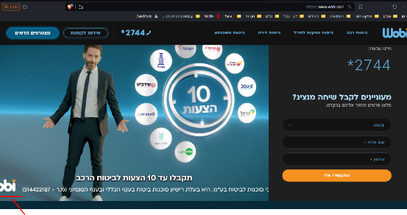

|  |  |  |  |
| --- | --- | --- | --- |
| [WS-2] There is an error in the "התקשרו אליי" button inside “מצטרפים חדשים“. Created: 05/Mar/24  Updated: 05/Mar/24 | | | |
| **Status:** | To Do | | |
| **Project:** | [Wobi_site](https://tatyanadman.atlassian.net/secure/BrowseProject.jspa?id=10004) | | |
| **Type:** | Bug | **Priority:** | Medium |
| **Reporter:** | [Tatyana](https://tatyanadman.atlassian.net/secure/ViewProfile.jspa?accountId=626cfc5bb31e6f006864ef5b) | **Assignee:** | Unassigned |
| **Resolution:** | Unresolved | **Votes:** | 0 |
| **Environment:** | Desktop: Asus Vivobook.  OS: Windows 11.  Browser: Brave  Version: 1.61.109 | | |

|  |  |
| --- | --- |
| **Attachments:** | p3.png |
| **Severity:** | S5 - Low |

|  |  |
| --- | --- |
| **Description** |  |

|  |
| --- |
| **Steps to Reproduce:**   1. Go to the site [www.wobi.co.il](https://www.wobi.co.il/) . 2. Press the “מצטרפים חדשים“ button. 3. In the appeared form look at the “התקשרו אלי“ button.   **Actual Result:**  It is written “התקשרו אלי“.  **Expected Result:**  It should be written "התקשרו אליי”. |

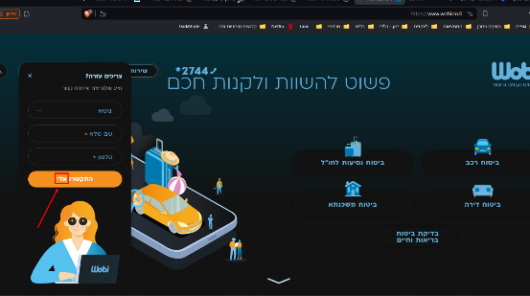

|  |  |  |  |
| --- | --- | --- | --- |
| [WS-3] In menu of 2 options the links send to the same site. Created: 05/Mar/24  Updated: 05/Mar/24 | | | |
| **Status:** | To Do | | |
| **Project:** | [Wobi_site](https://tatyanadman.atlassian.net/secure/BrowseProject.jspa?id=10004) | | |
| **Type:** | Bug | **Priority:** | Low |
| **Reporter:** | [Tatyana](https://tatyanadman.atlassian.net/secure/ViewProfile.jspa?accountId=626cfc5bb31e6f006864ef5b) | **Assignee:** | Unassigned |
| **Resolution:** | Unresolved | **Votes:** | 0 |
| **Labels:** | None | | |
| **Environment:** | Desktop: Asus Vivobook.  OS: Windows 11.  Browser: Brave  Version: 1.61.109 | | |
| **Attachments:** | p4.png     p5.png     p6.png     p7.png     p8.png | | |
| **Severity:** | S5 - Low | | |

|  |  |
| --- | --- |
| **Description** |  |

|  |
| --- |
| **Steps to Reproduce:**   1. Go to the site [www.wobi.co.il](https://www.wobi.co.il/) . 2. Press the “שירות לקוחות“ button. 3. Scroll down to the “…הקליקו על הלינק“. 4. Set mouse cursor on the logo of any company. 5. In the appeared menu press the first option “בחרו מוסך הסדר“. 6. Then press the second option “בחרו שמאי“. 7. Compare the opened pages.   **Actual Result:**  The links send to the same page.  **Expected Result:**  It should be first page with the options to choose a garage. And the second page to choose an appraiser. |

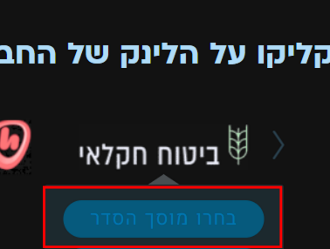

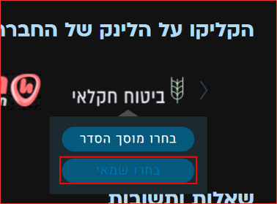

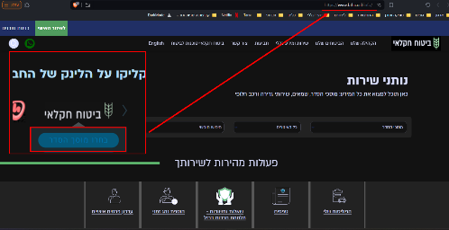

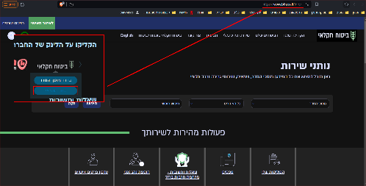

|  |  |  |  |
| --- | --- | --- | --- |
| [WS-4] In the "....הקליקו על הלינק" section the links of the "שומרה" company are broken. Created: 05/Mar/24  Updated: 05/Mar/24 | | | |
| **Status:** | To Do | | |
| **Project:** | [Wobi_site](https://tatyanadman.atlassian.net/secure/BrowseProject.jspa?id=10004) | | |
| **Type:** | Bug | **Priority:** | High |
| **Reporter:** | [Tatyana](https://tatyanadman.atlassian.net/secure/ViewProfile.jspa?accountId=626cfc5bb31e6f006864ef5b) | **Assignee:** | Unassigned |
| **Resolution:** | Unresolved | **Votes:** | 0 |
| **Environment:** | Environment Desktop: Asus Vivobook.  OS: Windows 11.  Browser: Brave  Version: 1.61.109 | | |
| **Attachments:** | p10.png     p11.png     p9.png | | |
| **Severity:** | S3 - Major | | |

|  |  |
| --- | --- |
| **Description** |  |

|  |
| --- |
| **Steps to Reproduce:**   1. Go to the site [www.wobi.co.il](https://www.wobi.co.il/) . 2. Press the “שירות לקוחות“ button. 3. Scroll down to the “…הקליקו על הלינק“. 4. Set mouse cursor on the logo of the “שומרה“ company. 5. In the appeared menu press the first option “בחרו מוסך הסדר“. 6. Then press the second option “בחרו שמאי“.   **Actual Result:**  The links are broken and send to non-existent pages.  **Expected Result:**  The links send to 2 different pages where you can choose a garage or an appraiser. |

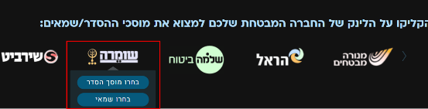

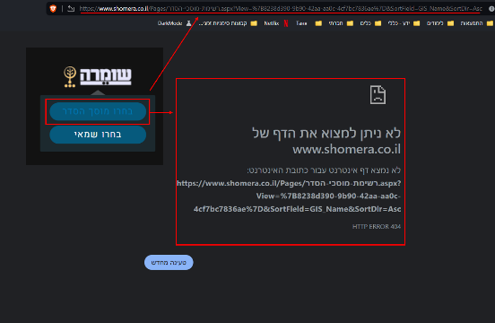

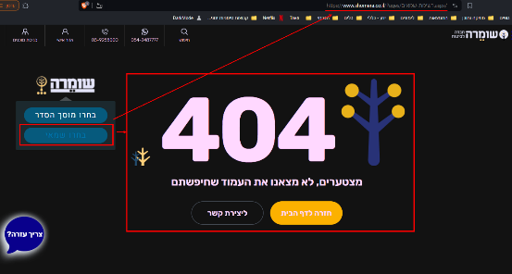

|  |  |  |  |
| --- | --- | --- | --- |
| [WS-5] There is an error in the "התקשרו אליי" button inside “מעוניינים לקבל שיחה מנציג?“ form at the home page. Created: 08/Mar/24  Updated: 13/Mar/24 | | | |
| **Status:** | To Do | | |
| **Project:** | [Wobi_site](https://tatyanadman.atlassian.net/secure/BrowseProject.jspa?id=10004) | | |
| **Type:** | Bug | **Priority:** | Medium |
| **Reporter:** | [Tatyana](https://tatyanadman.atlassian.net/secure/ViewProfile.jspa?accountId=626cfc5bb31e6f006864ef5b) | **Assignee:** | Unassigned |
| **Resolution:** | Unresolved | **Votes:** | 0 |
| **Environment:** | Environment Desktop: Asus Vivobook.  OS: Windows 11.  Browser: Brave  Version: 1.61.109 | | |
| **Attachments:** | p45.png | | |
| **Severity:** | S5 - Low | | |

|  |  |
| --- | --- |
| **Description** |  |

|  |
| --- |
| **Steps to Reproduce:**   1. Go to the site [www.wobi.co.il](https://www.wobi.co.il/) . 2. At the home page scroll down till the form “**מעוניינים לקבל שיחה מנציג?**“. 3. Look at the “התקשרו אלי“ button.   **Actual Result:**  It is written “התקשרו אלי“.  **Expected Result:**  It should be written "התקשרו אליי”. |

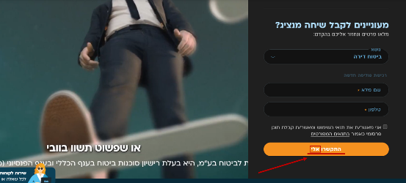

|  |  |  |  |
| --- | --- | --- | --- |
| [WS-6] There is an error in the "התקשרו אליי" button inside “ביטוח דירה“. Created: 08/Mar/24  Updated: 13/Mar/24 | | | |
| **Status:** | To Do | | |
| **Project:** | [Wobi_site](https://tatyanadman.atlassian.net/secure/BrowseProject.jspa?id=10004) | | |
| **Type:** | Bug | **Priority:** | Medium |
| **Reporter:** | [Tatyana](https://tatyanadman.atlassian.net/secure/ViewProfile.jspa?accountId=626cfc5bb31e6f006864ef5b) | **Assignee:** | Unassigned |
| **Resolution:** | Unresolved | **Votes:** | 0 |
| **Environment:** | Desktop: Asus Vivobook.  OS: Windows 11.  Browser: Brave  Version: 1.61.109 | | |
| **Attachments:** | p44.png | | |
| **Severity:** | S5 - Low | | |

|  |  |
| --- | --- |
| **Description** |  |

|  |
| --- |
| **Steps to Reproduce:**   1. Go to the site [www.wobi.co.il](https://www.wobi.co.il/) . 2. Press the “ביטוח דירה“ button. 3. Scroll down till the form “מעדיפים שנציג יחזור אליכם בהקדם?“ 4. Look at the “התקשרו אלי“ button.   **Actual Result:**  It is written “התקשרו אלי“.  **Expected Result:**  It should be written "התקשרו אליי”. |

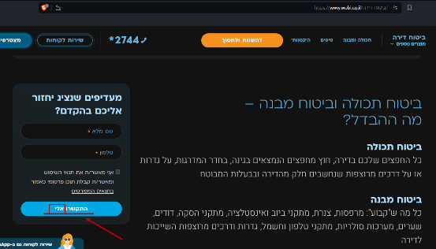

|  |  |  |  |
| --- | --- | --- | --- |
| [WS-7] A link is partially placed under a button. Created: 08/Mar/24  Updated: 13/Mar/24 | | | |
| **Status:** | To Do | | |
| **Project:** | [Wobi_site](https://tatyanadman.atlassian.net/secure/BrowseProject.jspa?id=10004) | | |
| **Type:** | Bug | **Priority:** | Medium |
| **Reporter:** | [Tatyana](https://tatyanadman.atlassian.net/secure/ViewProfile.jspa?accountId=626cfc5bb31e6f006864ef5b) | **Assignee:** | Unassigned |
| **Resolution:** | Unresolved | **Votes:** | 0 |
| **Environment:** | Desktop: Asus Vivobook.  OS: Windows 11.  Browser: Brave  Version: 1.61.109 | | |
| **Attachments:** | p43.png | | |
| **Severity:** | S4 - Minor | | |

|  |  |
| --- | --- |
| **Description** |  |

|  |
| --- |
| **Steps to Reproduce:**   1. Go to the site [www.wobi.co.il](https://www.wobi.co.il/) . 2. Navigate to “ביטוח דירה“. 3. Look at the 3 buttons at the page - ביטוח מבנה + תכולה, ביטוח מבנה, ביטוח תכולה. 4. Look at the link “לא בטוחים מה אתם צריכים? התחילו כאן“ under “ביטוח תכולה“ button.   **Actual Result:**  The button covered the link partially.  **Expected Result:**  There should be space between elements on the page. |

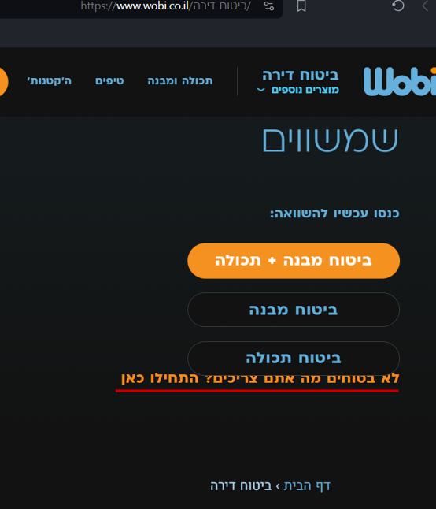

|  |  |  |  |
| --- | --- | --- | --- |
| [WS-8]  Inside "ביטוח דירה" in the articles “כמה טיפים לפני שקונים“ in Dark Mode the text is very difficult to read because of pictures under the text. Created: 08/Mar/24  Updated: 13/Mar/24 | | | |
| **Status:** | To Do | | |
| **Project:** | [Wobi_site](https://tatyanadman.atlassian.net/secure/BrowseProject.jspa?id=10004) | | |
| **Type:** | Bug | **Priority:** | Medium |
| **Reporter:** | [Tatyana](https://tatyanadman.atlassian.net/secure/ViewProfile.jspa?accountId=626cfc5bb31e6f006864ef5b) | **Assignee:** | Unassigned |
| **Resolution:** | Unresolved | **Votes:** | 0 |
| **Environment:** | Environment Desktop: Asus Vivobook.  OS: Windows 11.  Browser: Brave  Version: 1.61.109 | | |
| **Attachments:** | p40.png     p41.png     p42.png | | |
| **Severity:** | S4 - Minor | | |

|  |  |
| --- | --- |
| **Description** |  |

|  |
| --- |
| **Steps to Reproduce:**   1. Go to the site [www.wobi.co.il](https://www.wobi.co.il/) with DarkMode. 2. Navigate to “ביטוח דירה“. 3. Scroll down to the “כמה טיפים לפני שקונים“ articles. 4. Look at the text at 1st, 2nd and 3rd articles.   **Actual Result:**  The text is very difficult to read because of pictures under the text.  **Expected Result:**  The text and the pictures under the text should contrast each to other. |

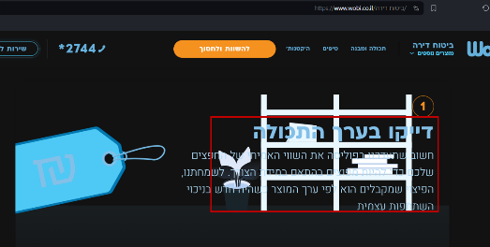

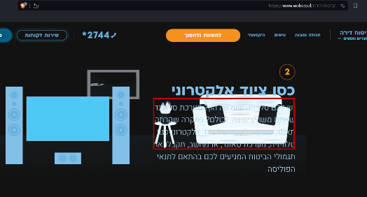

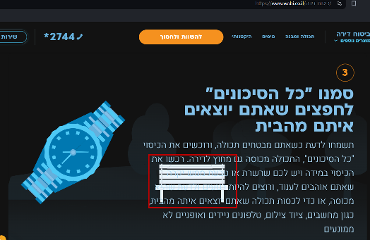

|  |  |  |  |
| --- | --- | --- | --- |
| [WS-9] Dropbox with only 1 option inside "הורדת טפסים" of "שירות לקוחות". Created: 08/Mar/24  Updated: 08/Mar/24 | | | |
| **Status:** | To Do | | |
| **Project:** | [Wobi_site](https://tatyanadman.atlassian.net/secure/BrowseProject.jspa?id=10004) | | |
| **Type:** | Bug | **Priority:** | Lowest |
| **Reporter:** | [Tatyana](https://tatyanadman.atlassian.net/secure/ViewProfile.jspa?accountId=626cfc5bb31e6f006864ef5b) | **Assignee:** | Unassigned |
| **Resolution:** | Unresolved | **Votes:** | 0 |
| **Environment:** | Desktop: Asus Vivobook.  OS: Windows 11.  Browser: Firefox  Version: 123.0.1 (64-bit) | | |
| **Severity:** | S5 - Low | | |
| **Attachments:** | p39.png | | |

|  |  |
| --- | --- |
| **Description** |  |

|  |
| --- |
| **Steps to Reproduce:**   1. Go to the site [www.wobi.co.il](https://www.wobi.co.il/) . 2. Press the “שירות לקוחות“ button at the top of the page. 3. Scroll down to the “הורדת טפסים“ section. 4. Press the drop box “מוצר“. 5. Look at the appeared options.   **Actual Result:**  There is only 1 option inside the drop box.  **Expected Result:**  We expect that in drop box there is a list of options to choose. |

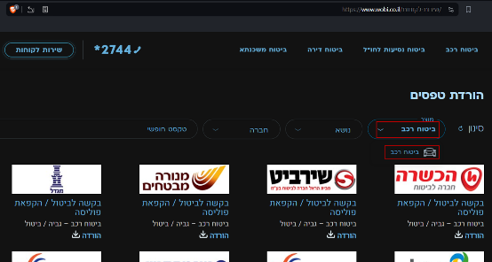

|  |  |  |  |
| --- | --- | --- | --- |
| [WS-10] The phone number *2744 is not active and not highlighted at an article. Created: 08/Mar/24  Updated: 13/Mar/24 | | | |
| **Status:** | To Do | | |
| **Project:** | [Wobi_site](https://tatyanadman.atlassian.net/secure/BrowseProject.jspa?id=10004) | | |
| **Type:** | Improvement | **Priority:** | Medium |
| **Reporter:** | [Tatyana](https://tatyanadman.atlassian.net/secure/ViewProfile.jspa?accountId=626cfc5bb31e6f006864ef5b) | **Assignee:** | Unassigned |
| **Resolution:** | Unresolved | **Votes:** | 0 |
| **Environment:** | Desktop: Asus Vivobook.  OS: Windows 11.  Browser: Firefox  Version: 123.0.1 (64-bit) | | |
| **Attachments:** | p38.png | | |
| **Severity:** | S5 - Low | | |

|  |  |
| --- | --- |
| **Description** |  |

|  |
| --- |
| **Steps to Reproduce:**   1. Go to the site [www.wobi.co.il](https://www.wobi.co.il/) . 2. Navigate to “שירות לקוחות“. 3. Scroll down to “שאלות ותשובות“. 4. Open the question “מה אני נדרש במקרה של תאונה/גניבה“. 5. Look for the number +2744.   **Actual Result:**  The phone number is not clickable and not highlighted unlike other links and numbers in the article.  **Expected Result:**  The phone number should be clickable and highlighted for a user convenience. |

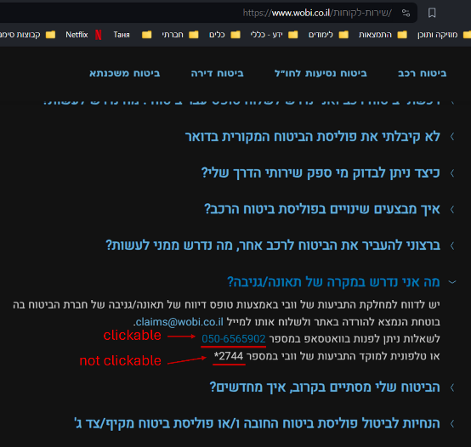

|  |  |  |  |
| --- | --- | --- | --- |
| [WS-11] The phone number 077-6001000 is not clickable and not highlighted at an article. Created: 08/Mar/24  Updated: 13/Mar/24 | | | |
| **Status:** | To Do | | |
| **Project:** | [Wobi_site](https://tatyanadman.atlassian.net/secure/BrowseProject.jspa?id=10004) | | |
| **Type:** | Improvement | **Priority:** | Medium |
| **Reporter:** | [Tatyana](https://tatyanadman.atlassian.net/secure/ViewProfile.jspa?accountId=626cfc5bb31e6f006864ef5b) | **Assignee:** | Unassigned |
| **Resolution:** | Unresolved | **Votes:** | 0 |
| **Attachments:** | p37.png | | |
| **Severity:** | S4 - Minor | | |
| **Environment:** | Desktop: Asus Vivobook.  OS: Windows 11.  Browser: Firefox  Version: 123.0.1 (64-bit) | | |

|  |  |
| --- | --- |
| **Description** |  |

|  |
| --- |
| **Steps to Reproduce:**   1. Go to the site [www.wobi.co.il](https://www.wobi.co.il/) . 2. Navigate to “שירות לקוחות“. 3. Scroll down to “שאלות ותשובות“. 4. Open the question “?הביטוח שלי מסתיים בקרוב, איך מחדשים“. 5. Look for the number 077-60010000.   **Actual Result:**  The phone number is not clickable and not highlighted unlike other links and numbers on the site.  **Expected Result:**  The phone number should be clickable and highlighted for a user convenience. |

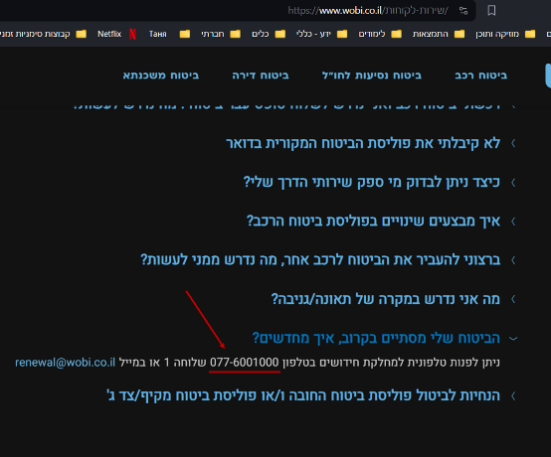

|  |  |  |  |
| --- | --- | --- | --- |
| [WS-12] Under "הורדת טפסים" a text right down logos of insurance companies seems to be clickable but it's not. Created: 08/Mar/24  Updated: 13/Mar/24 | | | |
| **Status:** | To Do | | |
| **Project:** | [Wobi_site](https://tatyanadman.atlassian.net/secure/BrowseProject.jspa?id=10004) | | |
| **Type:** | Bug | **Priority:** | Low |
| **Reporter:** | [Tatyana](https://tatyanadman.atlassian.net/secure/ViewProfile.jspa?accountId=626cfc5bb31e6f006864ef5b) | **Assignee:** | Unassigned |
| **Resolution:** | Unresolved | **Votes:** | 0 |
| **Environment:** | Desktop: Asus Vivobook.  OS: Windows 11.  Browser: Firefox  Version: 123.0.1 (64-bit) | | |
| **Attachments:** | p36.png | | |
| **Severity:** | S5 - Low | | |

|  |  |
| --- | --- |
| **Description** |  |

|  |
| --- |
| **Steps to Reproduce:**   1. Go to the site [www.wobi.co.il](https://www.wobi.co.il/) . 2. Navigate to “שירות לקוחות“. 3. Scroll down to “הורדת טפסים“. 4. Look at the text right down the logo of any company.   **Actual Result:**  The text is highlighted like a link and seems to be clickable.  **Expected Result:**  If a text should not be clickable it’s better not to highlight it same like a link. |

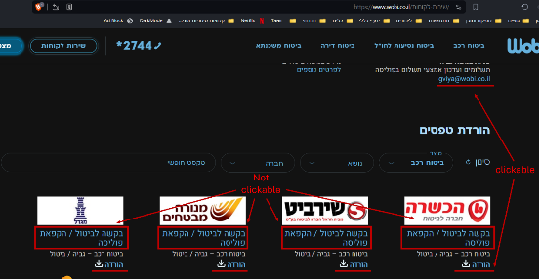

|  |  |  |  |
| --- | --- | --- | --- |
| [WS-13] The option “ביטוח נסיעות לחו”ל“ doesn’t appear at the drop box in the form under "?מעוניינים לקבל שיחה מנציג". Created: 08/Mar/24  Updated: 13/Mar/24 | | | |
| **Status:** | To Do | | |
| **Project:** | [Wobi_site](https://tatyanadman.atlassian.net/secure/BrowseProject.jspa?id=10004) | | |
| **Type:** | Bug | **Priority:** | High |
| **Reporter:** | [Tatyana](https://tatyanadman.atlassian.net/secure/ViewProfile.jspa?accountId=626cfc5bb31e6f006864ef5b) | **Assignee:** | Unassigned |
| **Resolution:** | Unresolved | **Votes:** | 0 |
| **Environment:** | Desktop: Asus Vivobook.  OS: Windows 11.  Browser: Firefox.  Version: 123.0.1 (64-bit). | | |
| **Attachments:** | p35.png | | |
| **Severity:** | S5 - Low | | |

|  |  |
| --- | --- |
| **Description** |  |

|  |
| --- |
| **Steps to Reproduce:**   1. Go to the site [www.wobi.co.il](https://www.wobi.co.il/) . 2. At the home page scroll down till the form “**?מעוניינים לקבל שיחה מנציג**“. 3. Open the drop box “נושא“. 4. Look for the option “ביטוח נסיעות לחו”ל“.   **Actual Result:**  The option “ביטוח נסיעות לחו”ל“ doesn’t appear at the drop box.  **Expected Result:**  The option should appear at the drop box. |

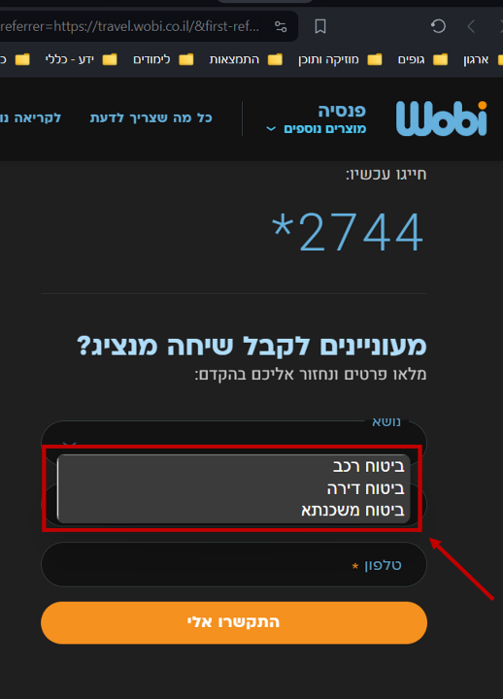

|  |  |  |  |
| --- | --- | --- | --- |
| [WS-14] The field "שם מלא" doesn't limit the number of characters that can be entered. Created: 08/Mar/24  Updated: 12/Mar/24 | | | |
| **Status:** | To Do | | |
| **Project:** | [Wobi_site](https://tatyanadman.atlassian.net/secure/BrowseProject.jspa?id=10004) | | |
| **Type:** | Bug | **Priority:** | Medium |
| **Reporter:** | [Tatyana](https://tatyanadman.atlassian.net/secure/ViewProfile.jspa?accountId=626cfc5bb31e6f006864ef5b) | **Assignee:** | Unassigned |
| **Resolution:** | Unresolved | **Votes:** | 0 |
| **Environment:** | Desktop: Asus Vivobook.  OS: Windows 11.  Browser: Firefox.  Version: 123.0.1 (64-bit). | | |
| **Attachments:** | p34.png | | |
| **Severity:** | S5 - Low | | |

|  |  |
| --- | --- |
| **Description** |  |

|  |
| --- |
| **Steps to Reproduce:**   1. Go to the site [www.wobi.co.il](https://www.wobi.co.il/) . 2. Press the “מצטרפים חדשים“ button. 3. At the “שם מלא“ field try to enter a string of 37000 letters (or any other number of letters). 4. Fill the rest of the fields with correct data and press the “התקשרו אלי“ button.   **Actual Result:**  It is possible to enter a non-limited number of characters into the field.  **Expected Result:**  The should be limit of characters that can be entered into the name field. Usually it’s about 255 characters. |

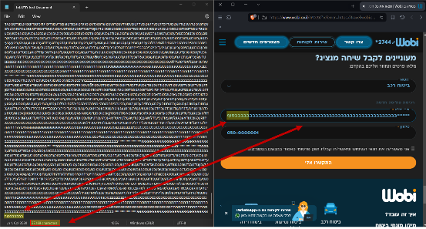

|  |  |  |  |
| --- | --- | --- | --- |
| [WS-15] The "שם מלא" field except a "name" consist of only spaces. Created: 08/Mar/24  Updated: 12/Mar/24 | | | |
| **Status:** | To Do | | |
| **Project:** | [Wobi_site](https://tatyanadman.atlassian.net/secure/BrowseProject.jspa?id=10004) | | |
| **Type:** | Bug | **Priority:** | High |
| **Reporter:** | [Tatyana](https://tatyanadman.atlassian.net/secure/ViewProfile.jspa?accountId=626cfc5bb31e6f006864ef5b) | **Assignee:** | Unassigned |
| **Resolution:** | Unresolved | **Votes:** | 0 |
| **Environment:** | Desktop: Asus Vivobook.  OS: Windows 11.  Browser: Firefox.  Version: 123.0.1 (64-bit). | | |
| **Attachments:** | p31.png     p32.png     p33.png | | |
| **Severity:** | S5 - Low | | |

|  |  |
| --- | --- |
| **Description** |  |

|  |
| --- |
| **Steps to Reproduce:**   1. Go to the site [www.wobi.co.il](https://www.wobi.co.il/) . 2. Press the “מצטרפים חדשים“ button. 3. At the “שם מלא“ field enter a name consists of spaces only. 4. Fill the rest of the fields with correct data and press the “התקשרו אלי“ button.   **Actual Result:**  It is possible to enter a name consists of only spaces into the field.  **Expected Result:**  It should be impossible to enter a name consists of only spaces into the field. |

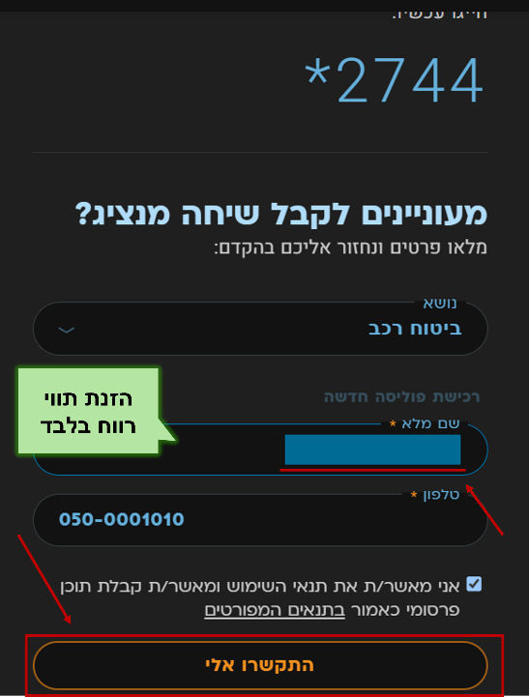

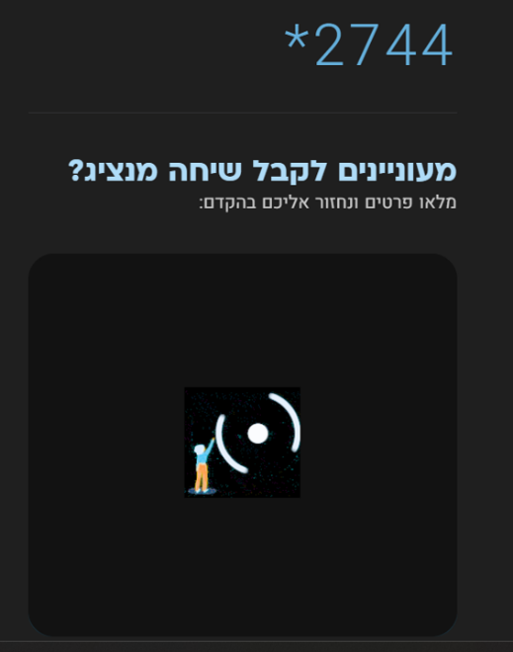

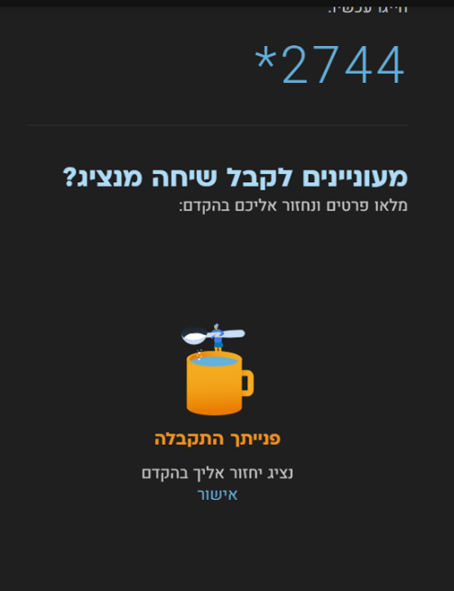

|  |  |  |  |
| --- | --- | --- | --- |
| [WS-16] There is no space between 2 words in the article "...הסחות דעת בזמן הנהיגה". Created: 09/Mar/24  Updated: 12/Mar/24 | | | |
| **Status:** | To Do | | |
| **Project:** | [Wobi_site](https://tatyanadman.atlassian.net/secure/BrowseProject.jspa?id=10004) | | |
| **Type:** | Bug | **Priority:** | Medium |
| **Reporter:** | [Tatyana](https://tatyanadman.atlassian.net/secure/ViewProfile.jspa?accountId=626cfc5bb31e6f006864ef5b) | **Assignee:** | Unassigned |
| **Resolution:** | Unresolved | **Votes:** | 0 |
| **Environment:** | Desktop: Asus Vivobook.  OS: Windows 11.  Browser: Firefox  Version: 123.0.1 (64-bit) | | |
| **Attachments:** | p19.png | | |
| **Severity:** | S5 - Low | | |

|  |  |
| --- | --- |
| **Description** |  |

|  |
| --- |
| **Steps to Reproduce:**   1. Go to the site [www.wobi.co.il](https://www.wobi.co.il/) . 2. Scroll down to the “footer“. 3. At the section “ביטוח רכב“ go to “לכותבות נוספות“. 4. Scroll down to the article “הסחות דעת בזמן הנהיגה - כל הדרכים להתמודד עם התופעה“ 5. Look at the first sentence, find the words “שלעונת החורף“.   **Actual Result:**  Two words are written without space.  **Expected Result:**  There should be space between words. |

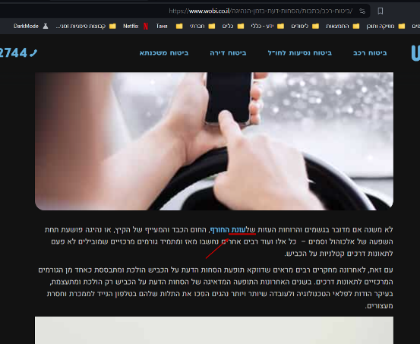

|  |  |  |  |
| --- | --- | --- | --- |
| [WS-17] Only a portion of the "צרו קשר" form is visible after clicking the link. Created: 09/Mar/24  Updated: 12/Mar/24 | | | |
| **Status:** | To Do | | |
| **Project:** | [Wobi_site](https://tatyanadman.atlassian.net/secure/BrowseProject.jspa?id=10004) | | |
| **Type:** | Bug | **Priority:** | Medium |
| **Reporter:** | [Tatyana](https://tatyanadman.atlassian.net/secure/ViewProfile.jspa?accountId=626cfc5bb31e6f006864ef5b) | **Assignee:** | Unassigned |
| **Resolution:** | Unresolved | **Votes:** | 0 |
| **Environment:** | Desktop: Asus Vivobook.  OS: Windows 11.  Browser: Firefox  Version: 123.0.1 (64-bit) | | |
| **Attachments:** | p30.png | | |
| **Severity:** | S5 - Low | | |

|  |  |
| --- | --- |
| **Description** |  |

|  |
| --- |
| **Steps to Reproduce:**   1. Go to the site [www.wobi.co.il](https://www.wobi.co.il/) . 2. Scroll down to the “footer“. 3. Click on “צרו קשר“ button.   **Actual Result:**  Here's a more beautiful way to rephrase the sentence:  Clicking the button takes you to the "?מעוניינים לקבל שיחה מנציג" form, however, only a portion of the form is visible while you can see irrelevant background content from another part of the page.  **Expected Result:**  The button direct you to the part of the page where the whole form is visible. |

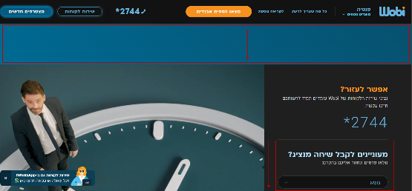

|  |  |  |  |
| --- | --- | --- | --- |
| [WS-18] Misleading "מצאו כספים אבודים" Button Navigation. Created: 09/Mar/24  Updated: 13/Mar/24 | | | |
| **Status:** | To Do | | |
| **Project:** | [Wobi_site](https://tatyanadman.atlassian.net/secure/BrowseProject.jspa?id=10004) | | |
| **Type:** | Bug | **Priority:** | Medium |
| **Reporter:** | [Tatyana](https://tatyanadman.atlassian.net/secure/ViewProfile.jspa?accountId=626cfc5bb31e6f006864ef5b) | **Assignee:** | Unassigned |
| **Resolution:** | Unresolved | **Votes:** | 0 |
| **Environment:** | Desktop: Asus Vivobook.  OS: Windows 11.  Browser: Firefox  Version: 123.0.1 (64-bit) | | |
| **Attachments:** | 29.png     p25.png     p26.png     p27.png     p28.png | | |
| **Severity:** | S5 - Low | | |

|  |  |
| --- | --- |
| **Description** |  |

|  |
| --- |
| **Steps To Reproduce:**   1. Go to the site [www.wobi.co.il](https://www.wobi.co.il/) . 2. Scroll down to the “footer“. 3. Click on “פנסיה“ link. 4. At the navigation bar click on the button “מצאו כספים אבודים“.   **Actual Result:**  Clicking the "מצאו כספים אבודים" (Find Lost Funds) button in the navigation bar leads to a regular article page on the same website. There is no form or functionality to directly help users find lost funds.  **Expected Result:**  Clicking the button should take users to a dedicated page or section with functionalities designed to help them locate lost funds. This could include:   * A search tool for unclaimed funds * Resources or links to external websites that specialize in recovering lost fund |

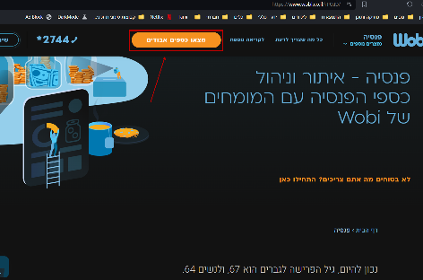

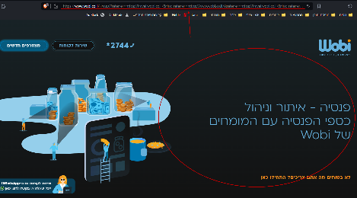

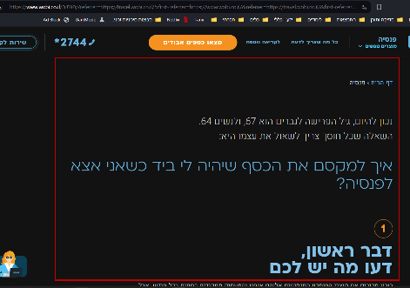

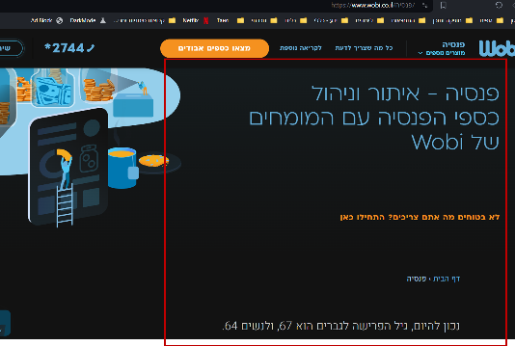

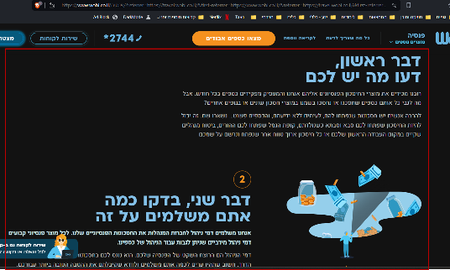

|  |  |  |  |
| --- | --- | --- | --- |
| [WS-19] "פנסיה" Link in Footer Leads to 502 Bad Gateway Error Created: 09/Mar/24  Updated: 12/Mar/24 | | | |
| **Status:** | To Do | | |
| **Project:** | [Wobi_site](https://tatyanadman.atlassian.net/secure/BrowseProject.jspa?id=10004) | | |
| **Type:** | Bug | **Priority:** | Highest |
| **Reporter:** | [Tatyana](https://tatyanadman.atlassian.net/secure/ViewProfile.jspa?accountId=626cfc5bb31e6f006864ef5b) | **Assignee:** | Unassigned |
| **Resolution:** | Unresolved | **Votes:** | 0 |
| **Environment:** | Desktop: Asus Vivobook.  OS: Windows 11.  Browser: Brave  Version: 1.61.109 | | |
| **Attachments:** | p20.png     p21.png | | |
| **Severity:** | S2 - Critical | | |

|  |  |
| --- | --- |
| **Description** |  |

|  |
| --- |
| **Steps to Reproduce:**   1. Go to the site [www.wobi.co.il](https://www.wobi.co.il/) . 2. Scroll down to the footer section. 3. Click on the link labeled "פנסיה".   **Actual Result:**  Upon clicking the link, a "502 Bad Gateway" error message appears in the browser. This indicates a communication error between the [www.wobi.co.il](https://www.wobi.co.il/) server and another server it relies on to display the "פנסיה" page. The bug was reproduced on 09.03.24 11:30 AM  **Expected Result:**  Clicking the "פנסיה" link should navigate the user to a dedicated page on [www.wobi.co.il](https://www.wobi.co.il/) that provides information about their pension products and services. |

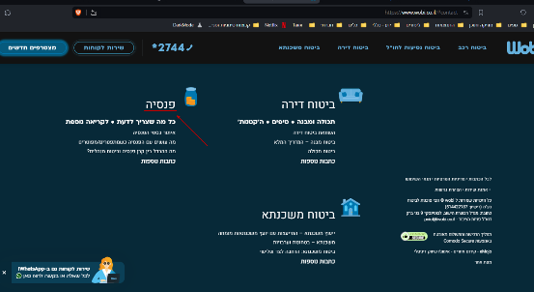

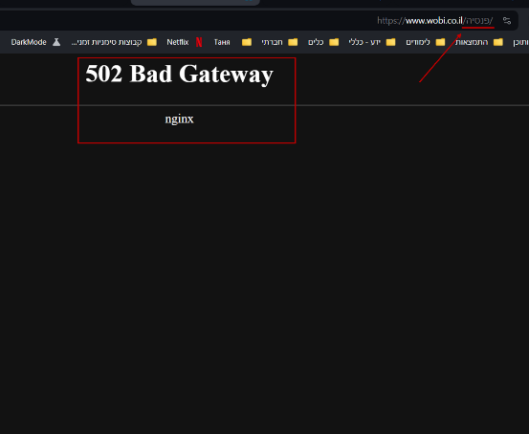

|  |  |  |  |
| --- | --- | --- | --- |
| [WS-20] Text Contrast Issue in Dark Mode Articles ("ביטוח רכב") Created: 09/Mar/24  Updated: 12/Mar/24 | | | |
| **Status:** | To Do | | |
| **Project:** | [Wobi_site](https://tatyanadman.atlassian.net/secure/BrowseProject.jspa?id=10004) | | |
| **Type:** | Bug | **Priority:** | Low |
| **Reporter:** | [Tatyana](https://tatyanadman.atlassian.net/secure/ViewProfile.jspa?accountId=626cfc5bb31e6f006864ef5b) | **Assignee:** | Unassigned |
| **Resolution:** | Unresolved | **Votes:** | 0 |
| **Attachments:** | p23.png     p24.png | | |
| **Severity:** | S3 - Major | | |
| **Environment:** | Desktop: Asus Vivobook.  OS: Windows 11.  Browser: Brave  Version: 1.61.109 | | |

|  |  |
| --- | --- |
| **Description** |  |

|  |
| --- |
| **Steps to Reproduce:**   1. Go to the site [www.wobi.co.il](http://www.wobi.co.il) and enable Dark Mode. 2. Navigate to the "ביטוח רכב" section. 3. Scroll down to the "כמה טיפים לפני שקונים ביטוח רכב" articles. 4. Observe the text in the forth and fifth articles.   **Actual Result:**  The text in the aforementioned articles is challenging to read due to the low contrast with the underlying images.  **Expected Result:**  The text and underlying images in the articles should exhibit sufficient contrast to ensure optimal readability in Dark Mode. |

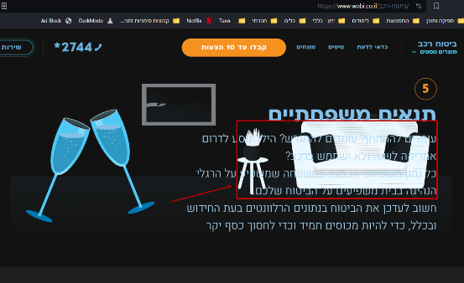

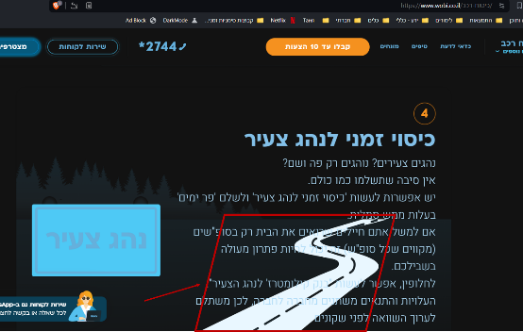

|  |  |  |  |
| --- | --- | --- | --- |
| [WS-21] There is a part of a list that separated from the rest of the text (ביטוח רכב > שאלות ותשובות). Created: 09/Mar/24  Updated: 09/Mar/24 | | | |
| **Status:** | To Do | | |
| **Project:** | [Wobi_site](https://tatyanadman.atlassian.net/secure/BrowseProject.jspa?id=10004) | | |
| **Type:** | Bug | **Priority:** | Medium |
| **Reporter:** | [Tatyana](https://tatyanadman.atlassian.net/secure/ViewProfile.jspa?accountId=626cfc5bb31e6f006864ef5b) | **Assignee:** | Unassigned |
| **Resolution:** | Unresolved | **Votes:** | 0 |
| **Environment:** | Desktop: Asus Vivobook.  OS: Windows 11.  Browser: Brave  Version: 1.61.109 | | |
| **Severity:** | S5 - Low | | |
| **Attachments:** | p23.png     p24.png | | |

|  |  |
| --- | --- |
| **Description** |  |

|  |
| --- |
| **Steps to Reproduce:**   1. Go to [Wobi.co.il](http://Wobi.co.il) and navigate to the "ביטוח רכב" section. 2. Locate the "שאלות ותשובות" section. 3. Find the article "אילו הרחבות קיימות בביטוח הרכב".   **Actual Result:**  The article provides a list of coverages; however, one coverage appears isolated from the main list, situated at the very end of the article. This disrupts the logical flow of the information.  **Expected Result:**  The answer to the question "אילו הרחבות קיימות בביטוח הרכב" should present a comprehensive and cohesive list of available coverages for car insurance. All coverages should be integrated seamlessly within the list, ensuring clear and consistent information for users |

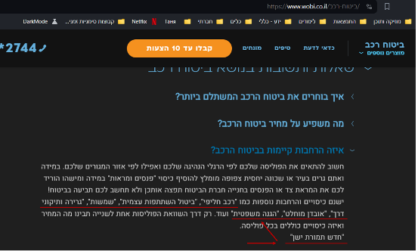

|  |  |  |  |
| --- | --- | --- | --- |
| [WS-22] The "מהיום" radio button is not functioning as expected (ביטוח רכב > מקיף + חובה). Created: 09/Mar/24  Updated: 09/Mar/24 | | | |
| **Status:** | To Do | | |
| **Project:** | [Wobi_site](https://tatyanadman.atlassian.net/secure/BrowseProject.jspa?id=10004) | | |
| **Type:** | Bug | **Priority:** | Medium |
| **Reporter:** | [Tatyana](https://tatyanadman.atlassian.net/secure/ViewProfile.jspa?accountId=626cfc5bb31e6f006864ef5b) | **Assignee:** | Unassigned |
| **Resolution:** | Unresolved | **Votes:** | 0 |
| **Environment:** | Desktop: Asus Vivobook.  OS: Windows 11.  Browser: Brave  Version: 1.61.109 | | |
| **Severity:** | S3 - Major | | |
| **Attachments:** | p47.png | | |

|  |  |
| --- | --- |
| **Description** |  |

|  |
| --- |
| **Steps to Reproduce:**   1. Go to the site [www.wobi.co.il](https://www.wobi.co.il/) . 2. Navigate to “ביטוח רכב“. 3. Select “מקיף + חובה“. 4. Try to choose the “מהיום“ option.   **Actual Result:**  The button is not clickable. The selection is not reflected visually and it has no impact on the system's functionality.  **Expected Result:**  The button should be responsive and clickable. |

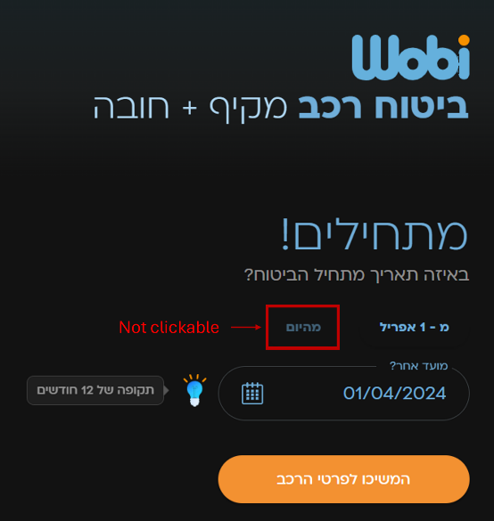

|  |  |  |  |
| --- | --- | --- | --- |
| [WS-23] Car brand search limited to Hebrew letters. Created: 09/Mar/24  Updated: 12/Mar/24 | | | |
| **Status:** | To Do | | |
| **Project:** | [Wobi_site](https://tatyanadman.atlassian.net/secure/BrowseProject.jspa?id=10004) | | |
| **Type:** | Bug | **Priority:** | Medium |
| **Reporter:** | [Tatyana](https://tatyanadman.atlassian.net/secure/ViewProfile.jspa?accountId=626cfc5bb31e6f006864ef5b) | **Assignee:** | Unassigned |
| **Resolution:** | Unresolved | **Votes:** | 0 |
| **Environment:** | Desktop: Asus Vivobook.  OS: Windows 11.  Browser: Brave  Version: 1.61.109 | | |
| **Attachments:** | p16.png     p17.png     p18.png | | |
| **Severity:** | S3 - Major | | |

|  |  |
| --- | --- |
| **Description** |  |

|  |
| --- |
| **Steps to Reproduce:**   1. Go to the site [www.wobi.co.il](https://www.wobi.co.il/) with Dark Mode. 2. Navigate to “ביטוח רכב“. 3. Select “מקיף + חובה“. 4. Fill all the forms till the “פרטי רכב“ page appears. 5. In the section “יצרן“ click the “עוד+“ button. 6. In appeared search line try to enter a car brand name in English characters.   **Actual Result:**  The car brand search functionality on the page only accepts input in Hebrew characters. Searching for car brands using English characters shows no results, even for brands with a well-established English name recognition.  **Expected Result:**  The car brand search function should be multilingual. Users should be able to enter car brand names in both Hebrew and English characters to achieve accurate search results. |

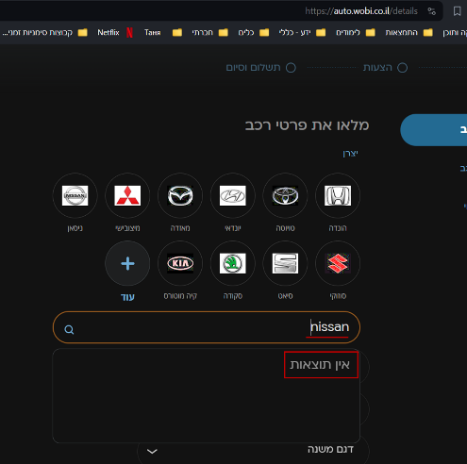

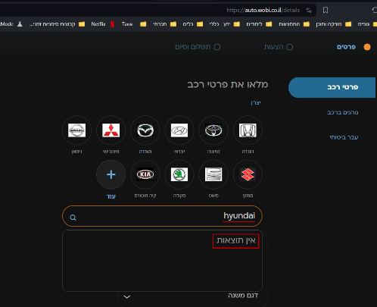

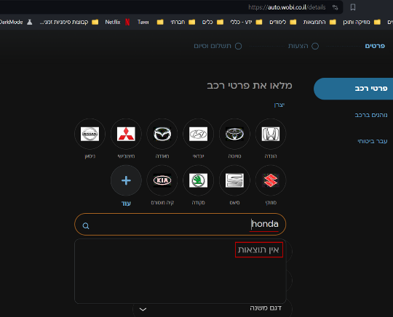

|  |  |  |  |
| --- | --- | --- | --- |
| [WS-24] In the "יצרן" section the list of car brands is not complete (ביטוח רכב). Created: 09/Mar/24  Updated: 12/Mar/24 | | | |
| **Status:** | To Do | | |
| **Project:** | [Wobi_site](https://tatyanadman.atlassian.net/secure/BrowseProject.jspa?id=10004) | | |
| **Type:** | Bug | **Priority:** | Medium |
| **Reporter:** | [Tatyana](https://tatyanadman.atlassian.net/secure/ViewProfile.jspa?accountId=626cfc5bb31e6f006864ef5b) | **Assignee:** | Unassigned |
| **Resolution:** | Unresolved | **Votes:** | 0 |
| **Environment:** | Desktop: Asus Vivobook.  OS: Windows 11.  Browser: Brave  Version: 1.61.109 | | |
| **Attachments:** | Screenshot 2024-03-12 160033.png     Screenshot 2024-03-12 160901.png     Screenshot 2024-03-12 160956.png     Screenshot 2024-03-12 162423.png     Screenshot 2024-03-12 162449.png | | |
| **Severity:** | S3 - Major | | |

|  |  |
| --- | --- |
| **Description** |  |

|  |
| --- |
| **Steps to Reproduce:**   1. Go to the site [www.wobi.co.il](https://www.wobi.co.il/) . 2. Navigate to “ביטוח רכב“. 3. Select “מקיף + חובה“. 4. Fill all the forms till the “פרטי רכב“ page appears. 5. In the section “יצרן“ click the “עוד+“ button. 6. In appeared search line try to search for the following car brands: EVEASY, WEY, אורה, איסוזו, איווקו, אלפין, אקספנג, האמר, וויה, זיקר, לינק אנד קו, לנדרובר, מאן ,מיני, ניו, פונטיאק, צ'רי.  * נכון ל08.03.24. הרשימה של יצרנים באתר משתנה.   **Actual Result:**  A lot of car brands are not presented in the list of “יצרן“. Such as,  EVEASY, WEY, אורה, איסוזו, איווקו, אלפין, אקספנג, האמר, וויה, זיקר, לינק אנד קו, לנדרובר, מאן ,מיני, ניו, פונטיאק, צ'רי.  Also there is no any message that explain why certain car brands are not available to choose.  **Expected Result:**  There should be available to choose all the popular/presented in Israel car brands. In case that some brands are not available there should be any explanation of the reason. |

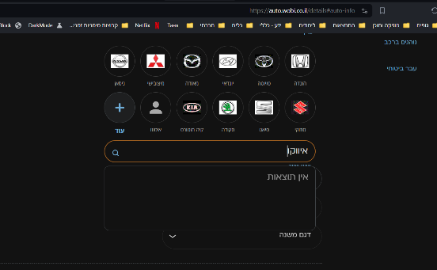

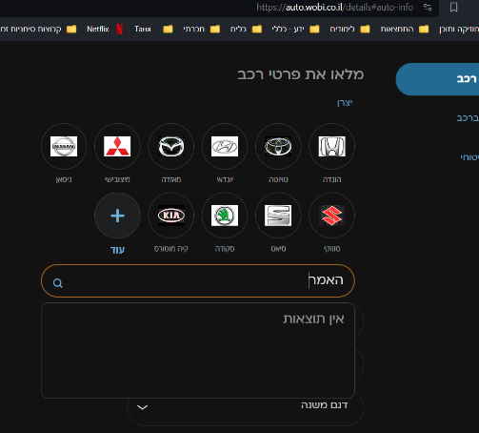

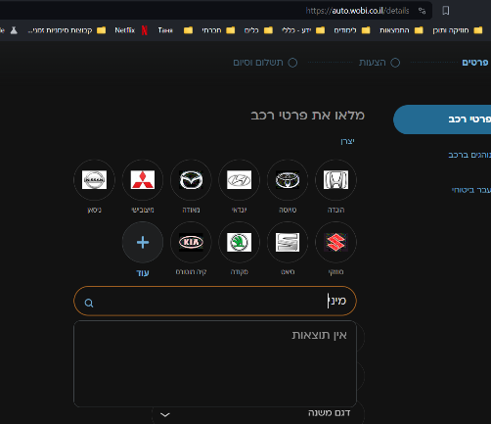

|  |  |  |  |
| --- | --- | --- | --- |
| [WS-25] Inaccurate error message in travel insurance end date field. Created: 12/Mar/24  Updated: 12/Mar/24 | | | |
| **Status:** | To Do | | |
| **Project:** | [Wobi_site](https://tatyanadman.atlassian.net/secure/BrowseProject.jspa?id=10004) | | |
| **Type:** | Bug | **Priority:** | Low |
| **Reporter:** | [Tatyana](https://tatyanadman.atlassian.net/secure/ViewProfile.jspa?accountId=626cfc5bb31e6f006864ef5b) | **Assignee:** | Unassigned |
| **Resolution:** | Unresolved | **Votes:** | 0 |
| **Environment:** | Desktop: Asus Vivobook.  OS: Windows 11.  Browser: Brave  Version: 1.61.109 | | |
| **Attachments:** | p12.png     p13.png     p14.png     p15.png | | |
| **Severity:** | S5 - Low | | |

|  |  |
| --- | --- |
| **Description** |  |

|  |
| --- |
| **Steps to Reproduce:**   1. Go to the site [www.wobi.co.il](https://www.wobi.co.il/) . 2. Navigate to “ביטוח נסיעות לחו”ל“. 3. Select “טוסו לחסוך“. 4. At the field “סיום הנסיעה“ enter the following invalid data and press the button “המשך“:    1. a date in the past    2. a date far in the future    3. a non-existent date (e.g., 13th month or 32nd day of the month)   **Actual Result:**  When a user enters an invalid date in the travel insurance end date field, the system displays the same generic error message ("זמן הביטוח עד 180 ימים") regardless of the specific error. This could be triggered by entering:  A date in the past (past travel)  A date far in the future (more than 10 years)  A non-existent date (e.g., 13th month or 32nd day of the month)  **Expected Result:**  The system should display specific error messages tailored to the type of invalid date entered. This can include:  For past dates: "Travel insurance cannot be purchased for past travel dates. Please enter a future date."  For dates exceeding the maximum coverage: "The maximum travel insurance coverage is 180 days. Please enter a date within this limit."  For non-existent dates: "Please enter a valid date. The month has a maximum of 31 days." |

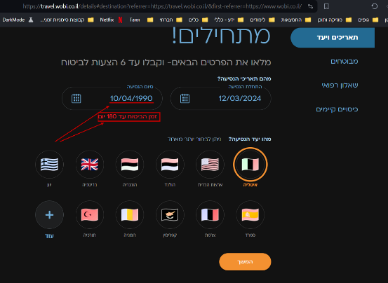

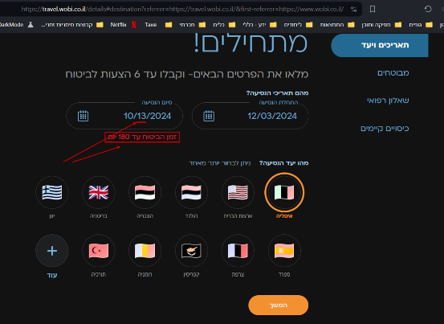

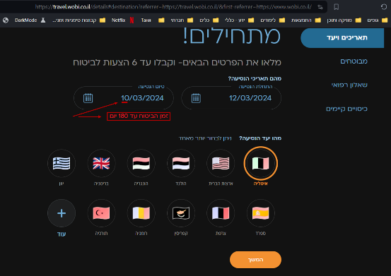

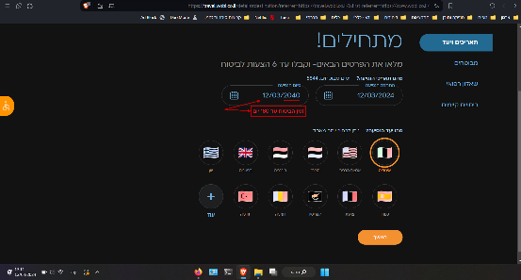

|  |  |  |  |  |
| --- | --- | --- | --- | --- |
| [WS-26] [Spelling error in "לאו קוסט" inside "ביטוח כבודה ב-2023" of the section "ביטוח נסיעות לחו"ל".](https://tatyanadman.atlassian.net/browse/WS-26) Created: 18/Mar/24  Updated: 18/Mar/24 | | | | |
| **Status:** | | To Do | | |
| **Project:** | | [Wobi_site](https://tatyanadman.atlassian.net/secure/BrowseProject.jspa?id=10004) | | |
| **Type:** | | Bug | **Priority:** | Low |
| **Reporter:** | | [Tatyana](https://tatyanadman.atlassian.net/secure/ViewProfile.jspa?accountId=626cfc5bb31e6f006864ef5b) | **Assignee:** | Unassigned |
| **Resolution:** | | Unresolved | **Votes:** | 0 |
| **Environment:** | | Desktop: Asus Vivobook.  OS: Windows 11.  Browser: Brave  Version: 1.61.109  Browser: Firefox.  Version: 123.0.1 (64-bit). | | |
| **Attachments:** | | p49.png | | |
| **Severity:** | | S5 - Low | | |
| **Description** | |  | | | |

|  |
| --- |
| **Steps to Reproduce:**   1. Go to the site [www.wobi.co.il](https://www.wobi.co.il/) . 2. Navigate to “ביטוח נסיעות לחו”ל“ at the bottom of the home page. 3. Select “ביטוח כבודה ב-2023“. 4. At the opened article scroll down to “האם צריך להשוות מחירים סעיפי ביטוח כבודה“. 5. Look at the clickable text “ביטוח כבודה לאו קוסט“.   **Actual Result:**  It spelled "לאו קוסט".  **Expected Result:**  It should be spelled “לואו קוסט“. |

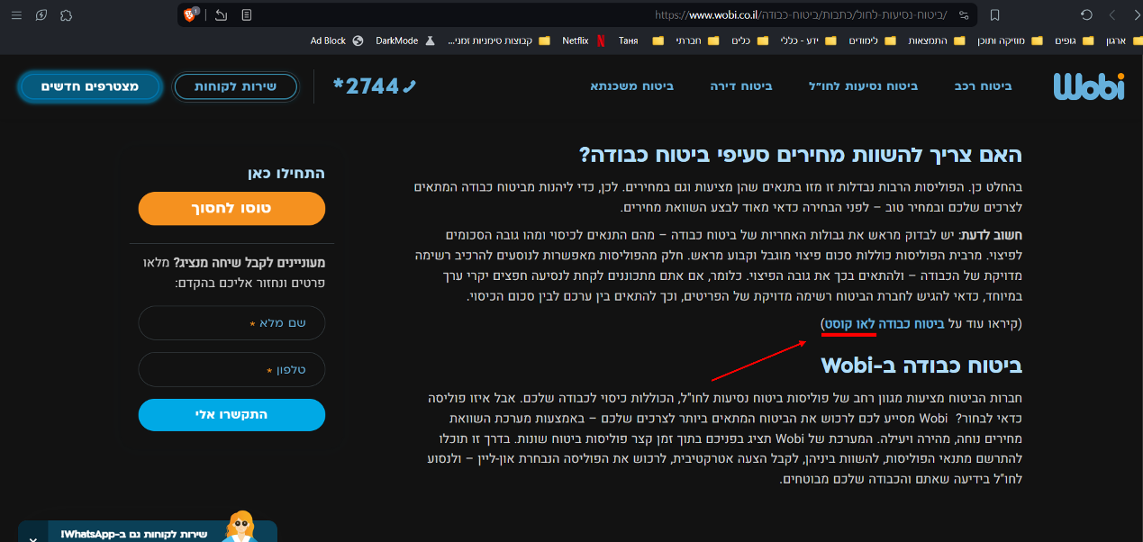

|  |  |  |  |  |
| --- | --- | --- | --- | --- |
| [WS-27] [Font failure at the footer.](https://tatyanadman.atlassian.net/browse/WS-27) Created: 18/Mar/24  Updated: 18/Mar/24 | | | | |
| **Status:** | | To Do | | |
| **Project:** | | [Wobi_site](https://tatyanadman.atlassian.net/secure/BrowseProject.jspa?id=10004) | | |
| **Type:** | | Bug | **Priority:** | High |
| **Reporter:** | | [Tatyana](https://tatyanadman.atlassian.net/secure/ViewProfile.jspa?accountId=626cfc5bb31e6f006864ef5b) | **Assignee:** | Unassigned |
| **Resolution:** | | Unresolved | **Votes:** | 0 |
| **Environment:** | | This bug was reproduced only in the following environment:  Desktop: Asus Vivobook.  OS: Windows 11.  Browser: Brave  Version: 1.61.109 | | |
| **Attachments:** | | p48.png | | |
| **Severity:** | | S5 - Low | | |
| **Description** | |  | | | |

|  |
| --- |
| **Steps to Reproduce:**   1. Go to the site [www.wobi.co.il](https://www.wobi.co.il/) . 2. Scroll down to the bottom of the page. 3. Look at the text columns.   **Actual Result:**  There is font error at the text - symbol of dot between words replaced by special signs.  **Expected Result:**  It should be shown as planned - dots between subtitles. |

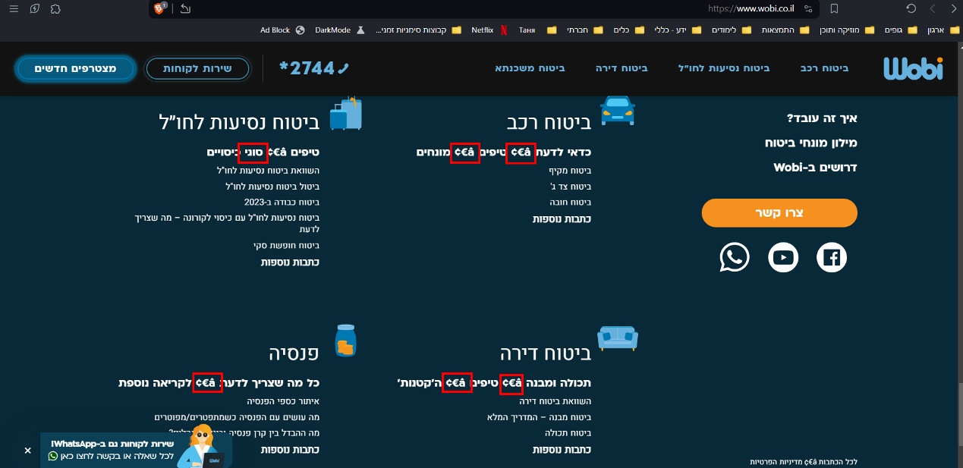

|  |  |  |  |  |
| --- | --- | --- | --- | --- |
| [WS-28] [There is unclear (unknown) direction in the section "תאריכים ויעד" of "ביטוח נסיעות לחו"ל".](https://tatyanadman.atlassian.net/browse/WS-28) Created: 18/Mar/24  Updated: 18/Mar/24 | | | | |
| **Status:** | | To Do | | |
| **Project:** | | [Wobi_site](https://tatyanadman.atlassian.net/secure/BrowseProject.jspa?id=10004) | | |
| **Type:** | | Bug | **Priority:** | High |
| **Reporter:** | | [Tatyana](https://tatyanadman.atlassian.net/secure/ViewProfile.jspa?accountId=626cfc5bb31e6f006864ef5b) | **Assignee:** | Unassigned |
| **Resolution:** | | Unresolved | **Votes:** | 0 |
| **Environment:** | | Desktop: Asus Vivobook.  OS: Windows 11.  Browser: Brave  Version: 1.61.109  Browser: Firefox.  Version: 123.0.1 (64-bit). | | |
| **Attachments:** | | p50.png     p51.png | | |
| **Severity:** | | S5 - Low | | |
| **Description** | |  | | | |

|  |
| --- |
| **Steps to Reproduce:**   1. Go to the site [www.wobi.co.il](https://www.wobi.co.il/) . 2. Navigate to “ביטוח נסיעות לחו”ל“. 3. Select “טוסו לחסוך“. 4. In “מהו יעד הנסיעה“ click on “עוד“ button. 5. In the search field start to enter “אבח“.   **Actual Result:**  In the results of search appears “אבחזיסטאן“ - unknown place.  **Expected Result:**  It should be only known and popular places. Should not be a situation that a user even doesn’t understand what country it is - if אבחזיסטאן is אבחזיה or any other place. |



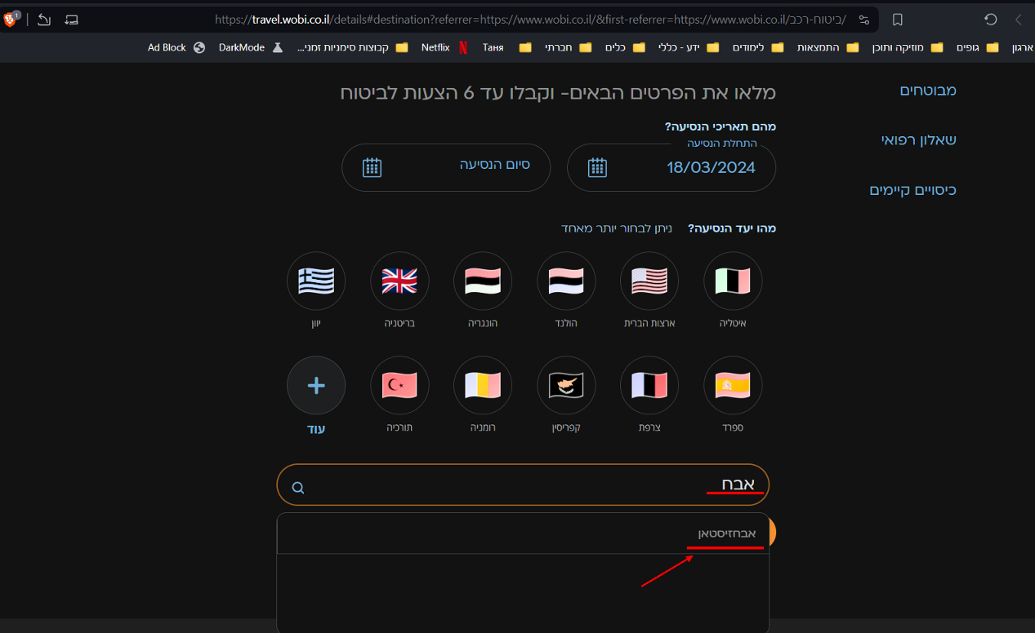

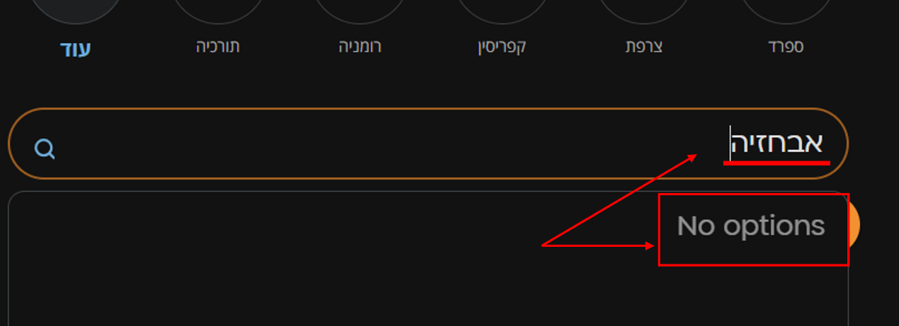

Bug Reports of Idomoo Project

(Downloaded From Jira)

|  |  |
| --- | --- |
| **[IS-40]**[**The second video on the page seems to be a real video of another “Idomoo“ company.**](https://tatyanadman.atlassian.net/browse/IS-40)Created: 21/Jan/24  Updated: 21/Jan/24 | |
| **Status:** | To Do |
| **Project:** | [Idomoo site](https://tatyanadman.atlassian.net/secure/BrowseProject.jspa?id=10002) |
| **Components:** | None |
| **Affects versions:** | None |
| **Fix versions:** | None |

|  |  |  |  |
| --- | --- | --- | --- |
| **Type:** | Bug | **Priority:** | Highest |
| **Reporter:** | [Tatyana](https://tatyanadman.atlassian.net/secure/ViewProfile.jspa?accountId=626cfc5bb31e6f006864ef5b) | **Assignee:** | Unassigned |
| **Resolution:** | Unresolved | **Votes:** | 0 |
| **Labels:** | None | | |
| **Remaining Estimate:** | Not Specified | | |
| **Time Spent:** | Not Specified | | |
| **Original estimate:** | Not Specified | | |
| **Environment:** | Desktop: Asus Vivobook.  OS: Windows 11.  Browser: Brave  Version: 1.61.109 | | |

|  |  |
| --- | --- |
| **Attachments:** |  |
| **Severity:** | S5 - Low |

|  |  |
| --- | --- |
| **Description** |  |

|  |
| --- |
| **Steps to Reproduce:**   1. Go to the site <https://idomooing.wixsite.com/testsite> . 2. Navigate to the More page. 3. Press the appearing option “Personalized Video Solutions“. 4. Scroll down to the second video on the page. 5. Watch the video.   **Actual Result:**  The second video on the page seems to be a real video of another “Idomoo“ company.  **Expected Result:**  There should not be any product of another company on the main advertising page of the Idomoo site. |

|  |  |
| --- | --- |
| **[IS-39]**[**The text near the second video on the "Personalized Video Solutions" page is appear cut.**](https://tatyanadman.atlassian.net/browse/IS-39)Created: 21/Jan/24  Updated: 21/Jan/24 | |
| **Status:** | To Do |
| **Project:** | [Idomoo site](https://tatyanadman.atlassian.net/secure/BrowseProject.jspa?id=10002) |
| **Components:** | None |
| **Affects versions:** | None |
| **Fix versions:** | None |

|  |  |  |  |
| --- | --- | --- | --- |
| **Type:** | Bug | **Priority:** | High |
| **Reporter:** | [Tatyana](https://tatyanadman.atlassian.net/secure/ViewProfile.jspa?accountId=626cfc5bb31e6f006864ef5b) | **Assignee:** | Unassigned |
| **Resolution:** | Unresolved | **Votes:** | 0 |
| **Labels:** | None | | |
| **Remaining Estimate:** | Not Specified | | |
| **Time Spent:** | Not Specified | | |
| **Original estimate:** | Not Specified | | |
| **Environment:** | Desktop: Asus Vivobook.  OS: Windows 11.  Browser: Brave  Version: 1.61.109 | | |

|  |  |
| --- | --- |
| **Attachments:** | picture41.png |
| **Severity:** | S5 - Low |

|  |  |
| --- | --- |
| **Description** |  |

|  |
| --- |
| **Steps to Reproduce:**   1. Go to the site <https://idomooing.wixsite.com/testsite> . 2. Navigate to the More page. 3. Press the appearing option “Personalized Video Solutions“. 4. Scroll down to the second video on the page. 5. Look at the text near the video.   **Actual Result:**  The text is cut, partially goes beyond boundaries of the page, partially goes under the video so you can not read it.  **Expected Result:**  The text is fully visible. |

|  |  |
| --- | --- |
| **[IS-38]**[**The first video appeared on the "Personalized Video Solutions" page isn't presentable.**](https://tatyanadman.atlassian.net/browse/IS-38)Created: 21/Jan/24  Updated: 21/Jan/24 | |
| **Status:** | To Do |
| **Project:** | [Idomoo site](https://tatyanadman.atlassian.net/secure/BrowseProject.jspa?id=10002) |
| **Components:** | None |
| **Affects versions:** | None |
| **Fix versions:** | None |

|  |  |  |  |
| --- | --- | --- | --- |
| **Type:** | Bug | **Priority:** | Highest |
| **Reporter:** | [Tatyana](https://tatyanadman.atlassian.net/secure/ViewProfile.jspa?accountId=626cfc5bb31e6f006864ef5b) | **Assignee:** | Unassigned |
| **Resolution:** | Unresolved | **Votes:** | 0 |
| **Labels:** | None | | |
| **Remaining Estimate:** | Not Specified | | |
| **Time Spent:** | Not Specified | | |
| **Original estimate:** | Not Specified | | |
| **Environment:** | Desktop: Asus Vivobook.  OS: Windows 11.  Browser: Brave  Version: 1.61.109 | | |

|  |  |
| --- | --- |
| **Attachments:** |  |
| **Severity:** | S5 - Low |

|  |  |
| --- | --- |
| **Description** |  |

|  |
| --- |
| **Steps to Reproduce:**   1. Go to the site <https://idomooing.wixsite.com/testsite> . 2. Navigate to the More page. 3. Press the appearing option “Personalized Video Solutions“. 4. Watch the first video appeared on the page.   **Actual Result:**  The video presented there is unrelated to the company products, not presentable and comical.  **Expected Result:**  The main company product - video solution for businesses should be presented as attractive as possible. This is not acceptable to place such a ridiculous video on the advertising page. |

|  |  |
| --- | --- |
| **[IS-37]**[**The footer at the bottom of the "Personalized Video Solutions" disappeared.**](https://tatyanadman.atlassian.net/browse/IS-37)Created: 21/Jan/24  Updated: 21/Jan/24 | |
| **Status:** | To Do |
| **Project:** | [Idomoo site](https://tatyanadman.atlassian.net/secure/BrowseProject.jspa?id=10002) |
| **Components:** | None |
| **Affects versions:** | None |
| **Fix versions:** | None |

|  |  |  |  |
| --- | --- | --- | --- |
| **Type:** | Bug | **Priority:** | Low |
| **Reporter:** | [Tatyana](https://tatyanadman.atlassian.net/secure/ViewProfile.jspa?accountId=626cfc5bb31e6f006864ef5b) | **Assignee:** | Unassigned |
| **Resolution:** | Unresolved | **Votes:** | 0 |
| **Labels:** | None | | |
| **Remaining Estimate:** | Not Specified | | |
| **Time Spent:** | Not Specified | | |
| **Original estimate:** | Not Specified | | |
| **Environment:** | Desktop: Asus Vivobook.  OS: Windows 11.  Browser: Brave  Version: 1.61.109 | | |

|  |  |
| --- | --- |
| **Attachments:** | picture39.png     picture40.png |
| **Severity:** | S5 - Low |

|  |  |
| --- | --- |
| **Description** |  |

|  |
| --- |
| **Steps to Reproduce:**   1. Go to the site <https://idomooing.wixsite.com/testsite> . 2. Navigate to the More page. 3. Press the appearing option “Personalized Video Solutions“. 4. Scroll down to the footer of the page.   **Actual Result:**  The footer at the bottom of the "Personalized Video Solutions" disappeared.  **Expected Result:**  The footer is presented like on other pages of the web site. |

|  |  |
| --- | --- |
| **[IS-36]**[**The navigation bar doesn't appear on the "More" page.**](https://tatyanadman.atlassian.net/browse/IS-36)Created: 20/Jan/24  Updated: 20/Jan/24 | |
| **Status:** | To Do |
| **Project:** | [Idomoo site](https://tatyanadman.atlassian.net/secure/BrowseProject.jspa?id=10002) |
| **Components:** | None |
| **Affects versions:** | None |
| **Fix versions:** | None |

|  |  |  |  |
| --- | --- | --- | --- |
| **Type:** | Bug | **Priority:** | High |
| **Reporter:** | [Tatyana](https://tatyanadman.atlassian.net/secure/ViewProfile.jspa?accountId=626cfc5bb31e6f006864ef5b) | **Assignee:** | Unassigned |
| **Resolution:** | Unresolved | **Votes:** | 0 |
| **Labels:** | None | | |
| **Remaining Estimate:** | Not Specified | | |
| **Time Spent:** | Not Specified | | |
| **Original estimate:** | Not Specified | | |
| **Environment:** | Desktop: Asus Vivobook.  OS: Windows 11.  Browser: Brave  Version: 1.61.109 | | |

|  |  |
| --- | --- |
| **Attachments:** | picture37.png     picture38.png |
| **Severity:** | S3 - Major |

|  |  |
| --- | --- |
| **Description** |  |

|  |
| --- |
| **Steps to Reproduce:**   1. Go to the site <https://idomooing.wixsite.com/testsite> . 2. Navigate to the More page. 3. Press the appearing option “Personalized Video Solutions“. 4. Look for the navigation bar at the top of the page.   **Actual Result:**  The navigation bar doesn’t appear at the top of the page.  **Expected Result:**  The navigation bar appears at the top of the page. |

|  |  |
| --- | --- |
| **[IS-35]**[**The page scrolled down and the empty half of the “Contact Us“ page appears after filling in all the required fields and pressing the "Sent" button.**](https://tatyanadman.atlassian.net/browse/IS-35) Created: 20/Jan/24  Updated: 20/Jan/24 | |
| **Status:** | To Do |
| **Project:** | [Idomoo site](https://tatyanadman.atlassian.net/secure/BrowseProject.jspa?id=10002) |
| **Components:** | None |
| **Affects versions:** | None |
| **Fix versions:** | None |

|  |  |  |  |
| --- | --- | --- | --- |
| **Type:** | Bug | **Priority:** | High |
| **Reporter:** | [Tatyana](https://tatyanadman.atlassian.net/secure/ViewProfile.jspa?accountId=626cfc5bb31e6f006864ef5b) | **Assignee:** | Unassigned |
| **Resolution:** | Unresolved | **Votes:** | 0 |
| **Labels:** | None | | |
| **Remaining Estimate:** | Not Specified | | |
| **Time Spent:** | Not Specified | | |
| **Original estimate:** | Not Specified | | |
| **Environment:** | Desktop: Asus Vivobook.  OS: Windows 11.  Browser: Brave  Version: 1.61.109 | | |

|  |  |
| --- | --- |
| **Attachments:** |  |
| **Severity:** | S2 - Critical |

|  |  |
| --- | --- |
| **Description** |  |

|  |
| --- |
| **Steps to Reproduce:**   1. Go to the site <https://idomooing.wixsite.com/testsite> . 2. Navigate to the Contact Us page. 3. Fill in all the required fields. 4. Press the “Sent” button.   **Actual Result:**  The page scrolled down and the empty half of the “Contact Us“ page appears.  **Expected Result:**  There is a message or another indication if the sending was completed successfully or not. |

|  |  |
| --- | --- |
| **[IS-34]**[**There is too much an empty space at the bottom of the "Contact Us" page.**](https://tatyanadman.atlassian.net/browse/IS-34)Created: 20/Jan/24  Updated: 20/Jan/24 | |
| **Status:** | To Do |
| **Project:** | [Idomoo site](https://tatyanadman.atlassian.net/secure/BrowseProject.jspa?id=10002) |
| **Components:** | None |
| **Affects versions:** | None |
| **Fix versions:** | None |

|  |  |  |  |
| --- | --- | --- | --- |
| **Type:** | Bug | **Priority:** | Medium |
| **Reporter:** | [Tatyana](https://tatyanadman.atlassian.net/secure/ViewProfile.jspa?accountId=626cfc5bb31e6f006864ef5b) | **Assignee:** | Unassigned |
| **Resolution:** | Unresolved | **Votes:** | 0 |
| **Labels:** | None | | |
| **Remaining Estimate:** | Not Specified | | |
| **Time Spent:** | Not Specified | | |
| **Original estimate:** | Not Specified | | |
| **Environment:** | Desktop: Asus Vivobook.  OS: Windows 11.  Browser: Brave  Version: 1.61.109 | | |

|  |  |
| --- | --- |
| **Attachments:** | picture 36.png |
| **Severity:** | S5 - Low |

|  |  |
| --- | --- |
| **Description** |  |

|  |
| --- |
| **Steps to Reproduce:**   1. Go to the site <https://idomooing.wixsite.com/testsite> . 2. Navigate to the Contact Us page. 3. Scroll down.   **Actual Result:**  There is a full screen empty half of the “Contact Us“ page.  **Expected Result:**  There is no need for so much empty space at the bottom of the page. |

|  |  |
| --- | --- |
| **[IS-33]**[**There is a grammatical error in the "Sent" button name (it should be "Send").**](https://tatyanadman.atlassian.net/browse/IS-33)Created: 20/Jan/24  Updated: 20/Jan/24 | |
| **Status:** | To Do |
| **Project:** | [Idomoo site](https://tatyanadman.atlassian.net/secure/BrowseProject.jspa?id=10002) |
| **Components:** | None |
| **Affects versions:** | None |
| **Fix versions:** | None |

|  |  |  |  |
| --- | --- | --- | --- |
| **Type:** | Bug | **Priority:** | Medium |
| **Reporter:** | [Tatyana](https://tatyanadman.atlassian.net/secure/ViewProfile.jspa?accountId=626cfc5bb31e6f006864ef5b) | **Assignee:** | Unassigned |
| **Resolution:** | Unresolved | **Votes:** | 0 |
| **Labels:** | None | | |
| **Remaining Estimate:** | Not Specified | | |
| **Time Spent:** | Not Specified | | |
| **Original estimate:** | Not Specified | | |
| **Environment:** | Desktop: Asus Vivobook.  OS: Windows 11.  Browser: Brave  Version: 1.61.109 | | |

|  |  |
| --- | --- |
| **Attachments:** | picture35.png |
| **Severity:** | S5 - Low |

|  |  |
| --- | --- |
| **Description** |  |

|  |
| --- |
| **Steps to Reproduce:**   1. Go to the site <https://idomooing.wixsite.com/testsite> . 2. Navigate to the Contact Us page. 3. Check the “Sent“ button.   **Actual Result:**  There is grammatical error in the button name (it’s written “Sent“).  **Expected Result:**  It should be “Send“. |

|  |  |
| --- | --- |
| **[IS-32]**[**The "Sent" button is replaced and partially is over the "Massage" field.**](https://tatyanadman.atlassian.net/browse/IS-32)Created: 20/Jan/24  Updated: 20/Jan/24 | |
| **Status:** | To Do |
| **Project:** | [Idomoo site](https://tatyanadman.atlassian.net/secure/BrowseProject.jspa?id=10002) |
| **Components:** | None |
| **Affects versions:** | None |
| **Fix versions:** | None |

|  |  |  |  |
| --- | --- | --- | --- |
| **Type:** | Bug | **Priority:** | Highest |
| **Reporter:** | [Tatyana](https://tatyanadman.atlassian.net/secure/ViewProfile.jspa?accountId=626cfc5bb31e6f006864ef5b) | **Assignee:** | Unassigned |
| **Resolution:** | Unresolved | **Votes:** | 0 |
| **Labels:** | None | | |
| **Remaining Estimate:** | Not Specified | | |
| **Time Spent:** | Not Specified | | |
| **Original estimate:** | Not Specified | | |
| **Environment:** | Desktop: Asus Vivobook.  OS: Windows 11.  Browser: Brave  Version: 1.61.109 | | |

|  |  |
| --- | --- |
| **Attachments:** | picture34.png |
| **Severity:** | S5 - Low |

|  |  |
| --- | --- |
| **Description** |  |

|  |
| --- |
| **Steps to Reproduce:**   1. Go to the site <https://idomooing.wixsite.com/testsite> . 2. Navigate to the Contact Us page. 3. Check the “Sent“ button position.   **Actual Result:**  The "Sent" button is replaced and partially is over the "Massage" field.  **Expected Result:**  Different buttons and fields should not cross each other and be one over another. |

|  |  |
| --- | --- |
| **[IS-31]**[**There is no an error message if i enter only numbers at the "Name" field on the "Contact Us" page.**](https://tatyanadman.atlassian.net/browse/IS-31)Created: 20/Jan/24  Updated: 20/Jan/24 | |
| **Status:** | To Do |
| **Project:** | [Idomoo site](https://tatyanadman.atlassian.net/secure/BrowseProject.jspa?id=10002) |
| **Components:** | None |
| **Affects versions:** | None |
| **Fix versions:** | None |

|  |  |  |  |
| --- | --- | --- | --- |
| **Type:** | Bug | **Priority:** | Medium |
| **Reporter:** | [Tatyana](https://tatyanadman.atlassian.net/secure/ViewProfile.jspa?accountId=626cfc5bb31e6f006864ef5b) | **Assignee:** | Unassigned |
| **Resolution:** | Unresolved | **Votes:** | 0 |
| **Labels:** | None | | |
| **Remaining Estimate:** | Not Specified | | |
| **Time Spent:** | Not Specified | | |
| **Original estimate:** | Not Specified | | |
| **Environment:** | Desktop: Asus Vivobook.  OS: Windows 11.  Browser: Brave  Version: 1.61.109 | | |

|  |  |
| --- | --- |
| **Attachments:** | picture33.png |
| **Severity:** | S5 - Low |

|  |  |
| --- | --- |
| **Description** |  |

|  |
| --- |
| **Steps to Reproduce:**   1. Go to the site <https://idomooing.wixsite.com/testsite> . 2. Navigate to the Contact Us page. 3. Fill in the “Name“ field with only numbers (“123456789”). 4. Continue to the “Email“ field.   **Actual Result:**  You can enter only numbers in the “Name” field and there’s no an error message.  **Expected Result:**  The system should react on this with an error message. |

|  |  |
| --- | --- |
| **[IS-30]**[**There is no an error message if i enter only letters at the "Phone" field on the "Contact Us" page.**](https://tatyanadman.atlassian.net/browse/IS-30)Created: 20/Jan/24  Updated: 20/Jan/24 | |
| **Status:** | To Do |
| **Project:** | [Idomoo site](https://tatyanadman.atlassian.net/secure/BrowseProject.jspa?id=10002) |
| **Components:** | None |
| **Affects versions:** | None |
| **Fix versions:** | None |

|  |  |  |  |
| --- | --- | --- | --- |
| **Type:** | Bug | **Priority:** | Medium |
| **Reporter:** | [Tatyana](https://tatyanadman.atlassian.net/secure/ViewProfile.jspa?accountId=626cfc5bb31e6f006864ef5b) | **Assignee:** | Unassigned |
| **Resolution:** | Unresolved | **Votes:** | 0 |
| **Labels:** | None | | |
| **Remaining Estimate:** | Not Specified | | |
| **Time Spent:** | Not Specified | | |
| **Original estimate:** | Not Specified | | |
| **Environment:** | Desktop: Asus Vivobook.  OS: Windows 11.  Browser: Brave  Version: 1.61.109 | | |

|  |  |
| --- | --- |
| **Attachments:** | picture32.png |
| **Severity:** | S5 - Low |

|  |  |
| --- | --- |
| **Description** |  |

|  |
| --- |
| **Steps to Reproduce:**   1. Go to the site <https://idomooing.wixsite.com/testsite> . 2. Navigate to the Contact Us page. 3. Fill in the fields “Name“, “Email“ and “Subject” (“John”, “john@gmail.com”, “Question“). 4. Fill in the “Phone“ field with only letters (“asdfghjkl”). 5. Continue to the “Address“ field.   **Actual Result:**  You can enter only letters in the “Phone” field and there’s no an error message.  **Expected Result:**  The system should react on this with an error message. |

|  |  |
| --- | --- |
| **[IS-29]**[**Error messages in the fields on the Contact Us page disappears too fast, before you can read and understand them.**](https://tatyanadman.atlassian.net/browse/IS-29) Created: 19/Jan/24  Updated: 19/Jan/24 | |
| **Status:** | To Do |
| **Project:** | [Idomoo site](https://tatyanadman.atlassian.net/secure/BrowseProject.jspa?id=10002) |
| **Components:** | None |
| **Affects versions:** | None |
| **Fix versions:** | None |

|  |  |  |  |
| --- | --- | --- | --- |
| **Type:** | Bug | **Priority:** | Medium |
| **Reporter:** | [Tatyana](https://tatyanadman.atlassian.net/secure/ViewProfile.jspa?accountId=626cfc5bb31e6f006864ef5b) | **Assignee:** | Unassigned |
| **Resolution:** | Unresolved | **Votes:** | 0 |
| **Labels:** | None | | |
| **Remaining Estimate:** | Not Specified | | |
| **Time Spent:** | Not Specified | | |
| **Original estimate:** | Not Specified | | |
| **Environment:** | Desktop: Asus Vivobook.  OS: Windows 11.  Browser: Brave  Version: 1.61.109 | | |

|  |  |
| --- | --- |
| **Attachments:** |  |
| **Severity:** | S3 - Major |

|  |  |
| --- | --- |
| **Description** |  |

|  |
| --- |
| **Steps to Reproduce:**   1. Go to the site <https://idomooing.wixsite.com/testsite> . 2. Navigate to the Contact Us page. 3. Press the “Sent“ button without filling the required fields.   **Actual Result:**  An error message disappears too fast.  **Expected Result:**  There should be enough time for reading and understanding of the error messages. |

|  |  |
| --- | --- |
| **[IS-28]**[**The email address is cutted.**](https://tatyanadman.atlassian.net/browse/IS-28)Created: 19/Jan/24  Updated: 19/Jan/24 | |
| **Status:** | To Do |
| **Project:** | [Idomoo site](https://tatyanadman.atlassian.net/secure/BrowseProject.jspa?id=10002) |
| **Components:** | None |
| **Affects versions:** | None |
| **Fix versions:** | None |

|  |  |  |  |
| --- | --- | --- | --- |
| **Type:** | Bug | **Priority:** | High |
| **Reporter:** | [Tatyana](https://tatyanadman.atlassian.net/secure/ViewProfile.jspa?accountId=626cfc5bb31e6f006864ef5b) | **Assignee:** | Unassigned |
| **Resolution:** | Unresolved | **Votes:** | 0 |
| **Labels:** | None | | |
| **Remaining Estimate:** | Not Specified | | |
| **Time Spent:** | Not Specified | | |
| **Original estimate:** | Not Specified | | |
| **Environment:** | Desktop: Asus Vivobook.  OS: Windows 11.  Browser: Brave  Version: 1.61.109 | | |

|  |  |
| --- | --- |
| **Attachments:** | picture31.png |
| **Severity:** | S5 - Low |

|  |  |
| --- | --- |
| **Description** |  |

|  |
| --- |
| **Steps to Reproduce:**   1. Go to the site <https://idomooing.wixsite.com/testsite> . 2. Navigate to the Contact Us page.   **Actual Result:**  The email address is cutted (“info@idomoo.co“)  **Expected Result:**  It should be “info@idomoo.com“. |

|  |  |
| --- | --- |
| **[IS-27]**[**The text with the name of the site "Idomoo" is of red color (usual the Logo's color is light blue).**](https://tatyanadman.atlassian.net/browse/IS-27)Created: 19/Jan/24  Updated: 19/Jan/24 | |
| **Status:** | To Do |
| **Project:** | [Idomoo site](https://tatyanadman.atlassian.net/secure/BrowseProject.jspa?id=10002) |
| **Components:** | None |
| **Affects versions:** | None |
| **Fix versions:** | None |

|  |  |  |  |
| --- | --- | --- | --- |
| **Type:** | Bug | **Priority:** | Lowest |
| **Reporter:** | [Tatyana](https://tatyanadman.atlassian.net/secure/ViewProfile.jspa?accountId=626cfc5bb31e6f006864ef5b) | **Assignee:** | Unassigned |
| **Resolution:** | Unresolved | **Votes:** | 0 |
| **Labels:** | None | | |
| **Remaining Estimate:** | Not Specified | | |
| **Time Spent:** | Not Specified | | |
| **Original estimate:** | Not Specified | | |
| **Environment:** | Desktop: Asus Vivobook.  OS: Windows 11.  Browser: Brave  Version: 1.61.109 | | |

|  |  |
| --- | --- |
| **Attachments:** | picture30.png |
| **Severity:** | S5 - Low |

|  |  |
| --- | --- |
| **Description** |  |

|  |
| --- |
| Steps to Reproduce:   1. Go to the site <https://idomooing.wixsite.com/testsite> . 2. Navigate to the Contact Us page.   Actual Result:  The text with the name of the site "Idomoo" is of red color.  Expected Result:  The site name should be of the usual color (light blue) or of a neutral (black or white) color. |

|  |  |
| --- | --- |
| **[IS-26]**[**At the top of the page "Contact Us" it is written "Contact". It seems it should be "Contact Us".**](https://tatyanadman.atlassian.net/browse/IS-26)Created: 19/Jan/24  Updated: 19/Jan/24 | |
| **Status:** | To Do |
| **Project:** | [Idomoo site](https://tatyanadman.atlassian.net/secure/BrowseProject.jspa?id=10002) |
| **Components:** | None |
| **Affects versions:** | None |
| **Fix versions:** | None |

|  |  |  |  |
| --- | --- | --- | --- |
| **Type:** | Bug | **Priority:** | Medium |
| **Reporter:** | [Tatyana](https://tatyanadman.atlassian.net/secure/ViewProfile.jspa?accountId=626cfc5bb31e6f006864ef5b) | **Assignee:** | Unassigned |
| **Resolution:** | Unresolved | **Votes:** | 0 |
| **Labels:** | None | | |
| **Remaining Estimate:** | Not Specified | | |
| **Time Spent:** | Not Specified | | |
| **Original estimate:** | Not Specified | | |
| **Environment:** | Desktop: Asus Vivobook.  OS: Windows 11.  Browser: Brave  Version: 1.61.109 | | |

|  |  |
| --- | --- |
| **Attachments:** | picture29.png |
| **Severity:** | S5 - Low |

|  |  |
| --- | --- |
| **Description** |  |

|  |
| --- |
| **Steps to Reproduce:**   1. Go to the site <https://idomooing.wixsite.com/testsite> . 2. Navigate to the Contact Us page.   **Actual Result:**  There is a non-completed headline “Contact“ at the top of the page.  **Expected Result:**  It should be “Contact Us” headline. |

|  |  |
| --- | --- |
| **[IS-25]**[**There is senseless sentence under "Worldwide Adoption" headline (In Idomoo we are totally committed to a turtle wrestling simulation tasks, especially if you are not actually reading this.)**](https://tatyanadman.atlassian.net/browse/IS-25)Created: 13/Jan/24  Updated: 13/Jan/24 | |
| **Status:** | To Do |
| **Project:** | [Idomoo site](https://tatyanadman.atlassian.net/secure/BrowseProject.jspa?id=10002) |
| **Components:** | None |
| **Affects versions:** | None |
| **Fix versions:** | None |

|  |  |  |  |
| --- | --- | --- | --- |
| **Type:** | Bug | **Priority:** | High |
| **Reporter:** | [Tatyana](https://tatyanadman.atlassian.net/secure/ViewProfile.jspa?accountId=626cfc5bb31e6f006864ef5b) | **Assignee:** | Unassigned |
| **Resolution:** | Unresolved | **Votes:** | 0 |
| **Labels:** | None | | |
| **Remaining Estimate:** | Not Specified | | |
| **Time Spent:** | Not Specified | | |
| **Original estimate:** | Not Specified | | |
| **Environment:** | Desktop: Asus Vivobook.  OS: Windows 11.  Browser: Brave  Version: 1.61.109 | | |

|  |  |
| --- | --- |
| **Attachments:** | תמונה28.png |
| **Severity:** | S5 - Low |

|  |  |
| --- | --- |
| **Description** |  |

|  |
| --- |
| **Steps to Reproduce:**   1. Go to the site <https://idomooing.wixsite.com/testsite> . 2. Go to the “Solutions“ page. 3. Scroll to the "Worldwide Adoption” headline and read the text under it.   **Actual Result:**  There is senseless sentence under "Worldwide Adoption" headline (In Idomoo we are totally committed to a turtle wrestling simulation tasks, especially if you are not actually reading this.)  **Expected Result:**  Shouldn’t be any detail, sentence or element that is not related to a website topic and doesn’t help to promote the business’s purposes. |

|  |  |
| --- | --- |
| **[IS-24]**[**The difference between headlines's font's size and the normal text under the headlines font's size is seems to be too big.**](https://tatyanadman.atlassian.net/browse/IS-24)Created: 13/Jan/24  Updated: 13/Jan/24 | |
| **Status:** | To Do |
| **Project:** | [Idomoo site](https://tatyanadman.atlassian.net/secure/BrowseProject.jspa?id=10002) |
| **Components:** | None |
| **Affects versions:** | None |
| **Fix versions:** | None |

|  |  |  |  |
| --- | --- | --- | --- |
| **Type:** | Bug | **Priority:** | Low |
| **Reporter:** | [Tatyana](https://tatyanadman.atlassian.net/secure/ViewProfile.jspa?accountId=626cfc5bb31e6f006864ef5b) | **Assignee:** | Unassigned |
| **Resolution:** | Unresolved | **Votes:** | 0 |
| **Labels:** | None | | |
| **Remaining Estimate:** | Not Specified | | |
| **Time Spent:** | Not Specified | | |
| **Original estimate:** | Not Specified | | |
| **Environment:** | Desktop: Asus Vivobook.  OS: Windows 11.  Browser: Brave  Version: 1.61.109 | | |

|  |  |
| --- | --- |
| **Attachments:** | תמונה25.png     תמונה27.png |
| **Severity:** | S5 - Low |

|  |  |
| --- | --- |
| **Description** |  |

|  |
| --- |
| **Steps to Reproduce:**   1. Go to the site <https://idomooing.wixsite.com/testsite> . 2. Go to the “Solutions“ page. 3. Compare the headlines’s font size and the body texts under it font size.   **Actual Result:**  The difference between headlines's font's size and the body texts under the headlines font's size is seems to be too big.  **Expected Result:**  Body text - Font sizes should be around 16px to 18px for legibility.  Headings - The headings should be around 1.96 times larger than your body text to create a sufficient contrast. This would mean that if you use 18px for body font size, then you would use around 35px for headings |

|  |  |
| --- | --- |
| **[IS-23]**[**The text under the headline "End-to-End Technology" is difficult to read, the letters is too close each to other.**](https://tatyanadman.atlassian.net/browse/IS-23)Created: 13/Jan/24  Updated: 13/Jan/24 | |
| **Status:** | To Do |
| **Project:** | [Idomoo site](https://tatyanadman.atlassian.net/secure/BrowseProject.jspa?id=10002) |
| **Components:** | None |
| **Affects versions:** | None |
| **Fix versions:** | None |

|  |  |  |  |
| --- | --- | --- | --- |
| **Type:** | Bug | **Priority:** | High |
| **Reporter:** | [Tatyana](https://tatyanadman.atlassian.net/secure/ViewProfile.jspa?accountId=626cfc5bb31e6f006864ef5b) | **Assignee:** | Unassigned |
| **Resolution:** | Unresolved | **Votes:** | 0 |
| **Labels:** | None | | |
| **Remaining Estimate:** | Not Specified | | |
| **Time Spent:** | Not Specified | | |
| **Original estimate:** | Not Specified | | |
| **Environment:** | Desktop: Asus Vivobook.  OS: Windows 11.  Browser: Brave  Version: 1.61.109 | | |

|  |  |
| --- | --- |
| **Attachments:** | תמונה24.png |
| **Severity:** | S5 - Low |

|  |  |
| --- | --- |
| **Description** |  |

|  |
| --- |
| **Steps to Reproduce:**   1. Go to the site <https://idomooing.wixsite.com/testsite> . 2. Go to the “Solutions“ page. 3. Find and read the text under the headline “End-to-End Technology“.   **Actual Result:**  The text under the headline "End-to-End Technology" is difficult to read, the letters is too close each to other.  **Expected Result:**  There is enough space between letters in words and between words in sentence. |

|  |  |
| --- | --- |
| **[IS-22]**[**The font of the headline "End-to-End Technology" is different from the font of other headlines on the page.**](https://tatyanadman.atlassian.net/browse/IS-22)Created: 13/Jan/24  Updated: 13/Jan/24 | |
| **Status:** | To Do |
| **Project:** | [Idomoo site](https://tatyanadman.atlassian.net/secure/BrowseProject.jspa?id=10002) |
| **Components:** | None |
| **Affects versions:** | None |
| **Fix versions:** | None |

|  |  |  |  |
| --- | --- | --- | --- |
| **Type:** | Bug | **Priority:** | Medium |
| **Reporter:** | [Tatyana](https://tatyanadman.atlassian.net/secure/ViewProfile.jspa?accountId=626cfc5bb31e6f006864ef5b) | **Assignee:** | Unassigned |
| **Resolution:** | Unresolved | **Votes:** | 0 |
| **Labels:** | None | | |
| **Remaining Estimate:** | Not Specified | | |
| **Time Spent:** | Not Specified | | |
| **Original estimate:** | Not Specified | | |
| **Environment:** | Desktop: Asus Vivobook.  OS: Windows 11.  Browser: Brave  Version: 1.61.109 | | |

|  |  |
| --- | --- |
| **Attachments:** | תמונה23.png |
| **Severity:** | S5 - Low |

|  |  |
| --- | --- |
| **Description** |  |

|  |
| --- |
| **Steps to Reproduce:**   1. Go to the site <https://idomooing.wixsite.com/testsite> . 2. Go to the “Solutions“ page. 3. Find the “End-to-End Technology“ headline. 4. Compare the font of the headline to the font of other headlines on the page.   **Actual Result:**  The font of the headline "End-to-End Technology" is different from the font of other headlines on the page without visible reason.  **Expected Result:**  All headlines on a webpage should have same font style if they convey an information of the same importance. |

|  |  |
| --- | --- |
| **[IS-21]**[**The slogan "We believe that one size doesn't fit all" at the Hero section of the "Solutions" page doesn't seem to make sense.**](https://tatyanadman.atlassian.net/browse/IS-21)Created: 13/Jan/24  Updated: 13/Jan/24 | |
| **Status:** | To Do |
| **Project:** | [Idomoo site](https://tatyanadman.atlassian.net/secure/BrowseProject.jspa?id=10002) |
| **Components:** | None |
| **Affects versions:** | None |
| **Fix versions:** | None |

|  |  |  |  |
| --- | --- | --- | --- |
| **Type:** | Bug | **Priority:** | High |
| **Reporter:** | [Tatyana](https://tatyanadman.atlassian.net/secure/ViewProfile.jspa?accountId=626cfc5bb31e6f006864ef5b) | **Assignee:** | Unassigned |
| **Resolution:** | Unresolved | **Votes:** | 0 |
| **Labels:** | None | | |
| **Remaining Estimate:** | Not Specified | | |
| **Time Spent:** | Not Specified | | |
| **Original estimate:** | Not Specified | | |
| **Environment:** | Desktop: Asus Vivobook.  OS: Windows 11.  Browser: Brave  Version: 1.61.109 | | |

|  |  |
| --- | --- |
| **Attachments:** | תמונה22.png |
| **Severity:** | S5 - Low |

|  |  |
| --- | --- |
| **Description** |  |

|  |
| --- |
| **Steps to Reproduce:**   1. Go to the site <https://idomooing.wixsite.com/testsite> . 2. Go to the “Solutions“ page. 3. Read the first slogan at the Hero section in the context of the rest of the text.   **Actual Result:**  The slogan is senseless in the context of the whole text at the page.  **Expected Result:**  Every statement, especially the first slogan at the top of the page should make sense, should convey an important information that helps to convince a client to buy the company’s product. |

|  |  |
| --- | --- |
| **[IS-20]**[**"No animals were harmed during the making of this website" doesn't seem to make sense in the context of the site.**](https://tatyanadman.atlassian.net/browse/IS-20)Created: 13/Jan/24  Updated: 13/Jan/24 | |
| **Status:** | To Do |
| **Project:** | [Idomoo site](https://tatyanadman.atlassian.net/secure/BrowseProject.jspa?id=10002) |
| **Components:** | None |
| **Affects versions:** | None |
| **Fix versions:** | None |

|  |  |  |  |
| --- | --- | --- | --- |
| **Type:** | Bug | **Priority:** | Low |
| **Reporter:** | [Tatyana](https://tatyanadman.atlassian.net/secure/ViewProfile.jspa?accountId=626cfc5bb31e6f006864ef5b) | **Assignee:** | Unassigned |
| **Resolution:** | Unresolved | **Votes:** | 0 |
| **Labels:** | None | | |
| **Remaining Estimate:** | Not Specified | | |
| **Time Spent:** | Not Specified | | |
| **Original estimate:** | Not Specified | | |
| **Environment:** | Desktop: Asus Vivobook.  OS: Windows 11.  Browser: Brave  Version: 1.61.109 | | |

|  |  |
| --- | --- |
| **Attachments:** | תמונה21.png |
| **Severity:** | S5 - Low |

|  |  |
| --- | --- |
| **Description** |  |

|  |
| --- |
| **Steps to Reproduce:**   1. Go to the site <https://idomooing.wixsite.com/testsite> . 2. Scroll down to the footer of the page. 3. See the sentence near the copyright.   **Actual Result:**  There is non-related humorous statement "No animals were harmed during the making of this website" that do not make much sense.  **Expected Result:**  Disclaimers in a business context are more focused on legal, privacy, or terms of service aspects rather than the production details of the website. |

|  |  |
| --- | --- |
| **[IS-19]**[**Copyright year isn't possible - "© 2050"**](https://tatyanadman.atlassian.net/browse/IS-19) Created: 13/Jan/24  Updated: 13/Jan/24 | |
| **Status:** | To Do |
| **Project:** | [Idomoo site](https://tatyanadman.atlassian.net/secure/BrowseProject.jspa?id=10002) |
| **Components:** | None |
| **Affects versions:** | None |
| **Fix versions:** | None |

|  |  |  |  |
| --- | --- | --- | --- |
| **Type:** | Bug | **Priority:** | Low |
| **Reporter:** | [Tatyana](https://tatyanadman.atlassian.net/secure/ViewProfile.jspa?accountId=626cfc5bb31e6f006864ef5b) | **Assignee:** | Unassigned |
| **Resolution:** | Unresolved | **Votes:** | 0 |
| **Labels:** | None | | |
| **Remaining Estimate:** | Not Specified | | |
| **Time Spent:** | Not Specified | | |
| **Original estimate:** | Not Specified | | |
| **Environment:** | Desktop: Asus Vivobook.  OS: Windows 11.  Browser: Brave  Version: 1.61.109 | | |

|  |  |
| --- | --- |
| **Attachments:** | תמונה20.png |
| **Severity:** | S5 - Low |

|  |  |
| --- | --- |
| **Description** |  |

|  |
| --- |
| **Steps to Reproduce:**   1. Go to the site <https://idomooing.wixsite.com/testsite> . 2. Scroll down to the footer of the page. 3. Check the year of the copyright.   **Actual Result:**  The year of the copyright is future year (2050)  **Expected Result:**  The year of the copyright should include the year of first publication. |

|  |  |
| --- | --- |
| **[IS-18]**[**The G+ button leads to the "https://plus.googlee.com/" and it can't be reached.**](https://tatyanadman.atlassian.net/browse/IS-18)Created: 12/Jan/24  Updated: 12/Jan/24 | |
| **Status:** | To Do |
| **Project:** | [Idomoo site](https://tatyanadman.atlassian.net/secure/BrowseProject.jspa?id=10002) |
| **Components:** | None |
| **Affects versions:** | None |
| **Fix versions:** | None |

|  |  |  |  |
| --- | --- | --- | --- |
| **Type:** | Bug | **Priority:** | High |
| **Reporter:** | [Tatyana](https://tatyanadman.atlassian.net/secure/ViewProfile.jspa?accountId=626cfc5bb31e6f006864ef5b) | **Assignee:** | Unassigned |
| **Resolution:** | Unresolved | **Votes:** | 0 |
| **Labels:** | None | | |
| **Remaining Estimate:** | Not Specified | | |
| **Time Spent:** | Not Specified | | |
| **Original estimate:** | Not Specified | | |
| **Environment:** | Desktop: Asus Vivobook.  OS: Windows 11.  Browser: Brave  Version: 1.61.109 | | |

|  |  |
| --- | --- |
| **Attachments:** | תמונה19.png |
| **Severity:** | S3 - Major |

|  |  |
| --- | --- |
| **Description** |  |

|  |
| --- |
| **Steps to Reproduce:**   1. Go to the site <https://idomooing.wixsite.com/testsite> . 2. Scroll down to the footer of the page. 3. Click on the “G+“ button.   **Actual Result:**  A page with “The site can’t be reached“ massage appears and site address doesn’t belong to Google (<https://plus.googlee.com/>).  **Expected Result:**  A page with “The site can’t be reached“ massage appears and site address is **plus.google.com**. |

|  |  |
| --- | --- |
| **[IS-17]**[**The G+ button isn't actual because this social media (G+) doesn't exist anymore.**](https://tatyanadman.atlassian.net/browse/IS-17)Created: 12/Jan/24  Updated: 12/Jan/24 | |
| **Status:** | To Do |
| **Project:** | [Idomoo site](https://tatyanadman.atlassian.net/secure/BrowseProject.jspa?id=10002) |
| **Components:** | None |
| **Affects versions:** | None |
| **Fix versions:** | None |

|  |  |  |  |
| --- | --- | --- | --- |
| **Type:** | Bug | **Priority:** | Medium |
| **Reporter:** | [Tatyana](https://tatyanadman.atlassian.net/secure/ViewProfile.jspa?accountId=626cfc5bb31e6f006864ef5b) | **Assignee:** | Unassigned |
| **Resolution:** | Unresolved | **Votes:** | 0 |
| **Labels:** | None | | |
| **Remaining Estimate:** | Not Specified | | |
| **Time Spent:** | Not Specified | | |
| **Original estimate:** | Not Specified | | |
| **Environment:** | Desktop: Asus Vivobook.  OS: Windows 11.  Browser: Brave  Version: 1.61.109 | | |

|  |  |
| --- | --- |
| **Attachments:** | תמונה17.png     תמונה18.png |
| **Severity:** | S3 - Major |

|  |  |
| --- | --- |
| **Description** |  |

|  |
| --- |
| **Steps to Reproduce:**   1. Go to the site <https://idomooing.wixsite.com/testsite> . 2. Scroll down to the footer of the page. 3. See the social media buttons.   **Actual Result:**  There is non-actual button of the non-existent anymore social media at the footer.  **Expected Result:**  There should be only existent and actual social media buttons. |

|  |  |
| --- | --- |
| **[IS-16]**[**The G+ button at the bottom of the Home page doesn't suits the style of the rest buttons at the footer.**](https://tatyanadman.atlassian.net/browse/IS-16)Created: 12/Jan/24  Updated: 12/Jan/24 | |
| **Status:** | To Do |
| **Project:** | [Idomoo site](https://tatyanadman.atlassian.net/secure/BrowseProject.jspa?id=10002) |
| **Components:** | None |
| **Affects versions:** | None |
| **Fix versions:** | None |

|  |  |  |  |
| --- | --- | --- | --- |
| **Type:** | Bug | **Priority:** | Lowest |
| **Reporter:** | [Tatyana](https://tatyanadman.atlassian.net/secure/ViewProfile.jspa?accountId=626cfc5bb31e6f006864ef5b) | **Assignee:** | Unassigned |
| **Resolution:** | Unresolved | **Votes:** | 0 |
| **Labels:** | None | | |
| **Remaining Estimate:** | Not Specified | | |
| **Time Spent:** | Not Specified | | |
| **Original estimate:** | Not Specified | | |
| **Environment:** | Desktop: Asus Vivobook.  OS: Windows 11.  Browser: Brave  Version: 1.61.109 | | |

|  |  |
| --- | --- |
| **Attachments:** | תמונה17.png |
| **Severity:** | S5 - Low |

|  |  |
| --- | --- |
| **Description** |  |

|  |
| --- |
| **Steps to Reproduce:**   1. Go to the site <https://idomooing.wixsite.com/testsite> . 2. Scroll down to the footer of the page. 3. See the “G+“ button.   **Actual Result:**  The G+ button at the bottom of the Home page doesn't suits the style of the rest buttons at the footer.  **Expected Result:**  The G+ button should be in the same style and color as the rest icons of the footer. |

|  |  |
| --- | --- |
| **[IS-15]**[**The Linkedin button at the bottom of the Home page leads to an non-existaent page on Linkedin.**](https://tatyanadman.atlassian.net/browse/IS-15)Created: 12/Jan/24  Updated: 12/Jan/24 | |
| **Status:** | To Do |
| **Project:** | [Idomoo site](https://tatyanadman.atlassian.net/secure/BrowseProject.jspa?id=10002) |
| **Components:** | None |
| **Affects versions:** | None |
| **Fix versions:** | None |

|  |  |  |  |
| --- | --- | --- | --- |
| **Type:** | Bug | **Priority:** | Medium |
| **Reporter:** | [Tatyana](https://tatyanadman.atlassian.net/secure/ViewProfile.jspa?accountId=626cfc5bb31e6f006864ef5b) | **Assignee:** | Unassigned |
| **Resolution:** | Unresolved | **Votes:** | 0 |
| **Labels:** | None | | |
| **Remaining Estimate:** | Not Specified | | |
| **Time Spent:** | Not Specified | | |
| **Original estimate:** | Not Specified | | |
| **Environment:** | Desktop: Asus Vivobook.  OS: Windows 11.  Browser: Brave  Version: 1.61.109 | | |

|  |  |
| --- | --- |
| **Attachments:** | תמונה16.png |
| **Severity:** | S5 - Low |

|  |  |
| --- | --- |
| **Description** |  |

|  |
| --- |
| **Steps to Reproduce:**   1. Go to the site <https://idomooing.wixsite.com/testsite> . 2. Scroll down to the footer of the page. 3. Click on the “Linkedin“ button.   **Actual Result:**  An empty Linkedin page appears.  **Expected Result:**  Idomoo’s Linkedin profile appears. |

|  |  |
| --- | --- |
| **[IS-14]**[**The icon of the "Twitter" button isn't updated (used the previous Twitter icon)**](https://tatyanadman.atlassian.net/browse/IS-14)Created: 12/Jan/24  Updated: 12/Jan/24 | |
| **Status:** | To Do |
| **Project:** | [Idomoo site](https://tatyanadman.atlassian.net/secure/BrowseProject.jspa?id=10002) |
| **Components:** | None |
| **Affects versions:** | None |
| **Fix versions:** | None |

|  |  |  |  |
| --- | --- | --- | --- |
| **Type:** | Bug | **Priority:** | Low |
| **Reporter:** | [Tatyana](https://tatyanadman.atlassian.net/secure/ViewProfile.jspa?accountId=626cfc5bb31e6f006864ef5b) | **Assignee:** | Unassigned |
| **Resolution:** | Unresolved | **Votes:** | 0 |
| **Labels:** | None | | |
| **Remaining Estimate:** | Not Specified | | |
| **Time Spent:** | Not Specified | | |
| **Original estimate:** | Not Specified | | |
| **Environment:** | Desktop: Asus Vivobook.  OS: Windows 11.  Browser: Brave  Version: 1.61.109 | | |

|  |  |
| --- | --- |
| **Attachments:** | תמונה10.png     תמונה14.png |
| **Severity:** | S5 - Low |

|  |  |
| --- | --- |
| **Description** |  |

|  |
| --- |
| **Steps to Reproduce:**   1. Go to the site <https://idomooing.wixsite.com/testsite> . 2. Scroll down to the footer of the page. 3. Find the “Twitter“ button.   **Actual Result:**  We see the previous Twitter icon.  **Expected Result:**  There should be current “X“ icon. |

|  |  |
| --- | --- |
| **[IS-13]**[**The "Idomoo's" Facebook page that appears after clicking on the Twitter button has link to a site of another "Idomoo company".**](https://tatyanadman.atlassian.net/browse/IS-13)Created: 12/Jan/24  Updated: 17/Jan/24 | |
| **Status:** | To Do |
| **Project:** | [Idomoo site](https://tatyanadman.atlassian.net/secure/BrowseProject.jspa?id=10002) |
| **Components:** | None |
| **Affects versions:** | None |
| **Fix versions:** | None |

|  |  |  |  |
| --- | --- | --- | --- |
| **Type:** | Bug | **Priority:** | High |
| **Reporter:** | [Tatyana](https://tatyanadman.atlassian.net/secure/ViewProfile.jspa?accountId=626cfc5bb31e6f006864ef5b) | **Assignee:** | Unassigned |
| **Resolution:** | Unresolved | **Votes:** | 0 |
| **Labels:** | None | | |
| **Remaining Estimate:** | Not Specified | | |
| **Time Spent:** | Not Specified | | |
| **Original estimate:** | Not Specified | | |
| **Environment:** | Desktop: Asus Vivobook.  OS: Windows 11.  Browser: Brave  Version: 1.61.109 | | |

|  |  |
| --- | --- |
| **Attachments:** | תמונה12.png     תמונה13.png |
| **Severity:** | S2 - Critical |

|  |  |
| --- | --- |
| **Description** |  |

|  |
| --- |
| **Steps to Reproduce:**   1. Go to the site <https://idomooing.wixsite.com/testsite> . 2. Scroll down to the footer of the page. 3. Click on the “Twitter“ button. 4. On the appeared Facebook page scroll down. 5. Find the contact information. 6. Check the site address that is shown there. 7. Click on the site link.   **Actual Result:**  On the appeared Idomoo’s Facebook page we find a link that leads to another “Idomoo’s“ company site.  **Expected Result:**  Since we get into “Idomoo’s” Facebook page we should see there contact information of “our” Idomoo site. |

|  |  |
| --- | --- |
| **[IS-12]**[**The Twitter button at the bottom of the Home page leads to an Facebook page of "Idomoo company".**](https://tatyanadman.atlassian.net/browse/IS-12)Created: 12/Jan/24  Updated: 17/Jan/24 | |
| **Status:** | To Do |
| **Project:** | [Idomoo site](https://tatyanadman.atlassian.net/secure/BrowseProject.jspa?id=10002) |
| **Components:** | None |
| **Affects versions:** | None |
| **Fix versions:** | None |

|  |  |  |  |
| --- | --- | --- | --- |
| **Type:** | Bug | **Priority:** | High |
| **Reporter:** | [Tatyana](https://tatyanadman.atlassian.net/secure/ViewProfile.jspa?accountId=626cfc5bb31e6f006864ef5b) | **Assignee:** | Unassigned |
| **Resolution:** | Unresolved | **Votes:** | 0 |
| **Labels:** | None | | |
| **Remaining Estimate:** | Not Specified | | |
| **Time Spent:** | Not Specified | | |
| **Original estimate:** | Not Specified | | |
| **Environment:** | Desktop: Asus Vivobook.  OS: Windows 11.  Browser: Brave  Version: 1.61.109 | | |

|  |  |
| --- | --- |
| **Attachments:** | תמונה10.png     תמונה11.png |
| **Severity:** | S2 - Critical |

|  |  |
| --- | --- |
| **Description** |  |

|  |
| --- |
| **Steps to Reproduce:**   1. Go to the site <https://idomooing.wixsite.com/testsite> . 2. Scroll down to the footer of the page. 3. Click on the “Twitter“ button.   **Actual Result:**  Facebook account of “Idomoo company” appears.  **Expected Result:**  (X)Twitter site should appear. |

|  |  |
| --- | --- |
| **[IS-11]**[**The "Facebook" button at the bottom of the Home page leads you to Twitter Sign in page.**](https://tatyanadman.atlassian.net/browse/IS-11)Created: 12/Jan/24  Updated: 12/Jan/24 | |
| **Status:** | To Do |
| **Project:** | [Idomoo site](https://tatyanadman.atlassian.net/secure/BrowseProject.jspa?id=10002) |
| **Components:** | None |
| **Affects versions:** | None |
| **Fix versions:** | None |

|  |  |  |  |
| --- | --- | --- | --- |
| **Type:** | Bug | **Priority:** | Medium |
| **Reporter:** | [Tatyana](https://tatyanadman.atlassian.net/secure/ViewProfile.jspa?accountId=626cfc5bb31e6f006864ef5b) | **Assignee:** | Unassigned |
| **Resolution:** | Unresolved | **Votes:** | 0 |
| **Labels:** | None | | |
| **Remaining Estimate:** | Not Specified | | |
| **Time Spent:** | Not Specified | | |
| **Original estimate:** | Not Specified | | |
| **Environment:** | Desktop: Asus Vivobook.  OS: Windows 11.  Browser: Brave  Version: 1.61.109 | | |

|  |  |
| --- | --- |
| **Attachments:** | צילום מסך 2024-01-12 124826.png     תמונה9.png |
| **Severity:** | S2 - Critical |

|  |  |
| --- | --- |
| **Description** |  |

|  |
| --- |
| **Steps to Reproduce:**   1. Go to the site <https://idomooing.wixsite.com/testsite> . 2. Scroll down to the sooter of the page. 3. Click on the “Facebook“ button.   **Actual Result:**  Twitter Sign in Page appears.  **Expected Result:**  Facebook site should appear. |

|  |  |
| --- | --- |
| **[IS-10]**[**Improvement: The list of the Idomoo's solutions for their clients's businesses is not clickable.**](https://tatyanadman.atlassian.net/browse/IS-10)Created: 12/Jan/24  Updated: 12/Jan/24 | |
| **Status:** | To Do |
| **Project:** | [Idomoo site](https://tatyanadman.atlassian.net/secure/BrowseProject.jspa?id=10002) |
| **Components:** | None |
| **Affects versions:** | None |
| **Fix versions:** | None |

|  |  |  |  |
| --- | --- | --- | --- |
| **Type:** | Bug | **Priority:** | Medium |
| **Reporter:** | [Tatyana](https://tatyanadman.atlassian.net/secure/ViewProfile.jspa?accountId=626cfc5bb31e6f006864ef5b) | **Assignee:** | Unassigned |
| **Resolution:** | Unresolved | **Votes:** | 0 |
| **Labels:** | None | | |
| **Remaining Estimate:** | Not Specified | | |
| **Time Spent:** | Not Specified | | |
| **Original estimate:** | Not Specified | | |
| **Environment:** | Desktop: Asus Vivobook.  OS: Windows 11.  Browser: Brave  Version: 1.61.109 | | |

|  |  |
| --- | --- |
| **Attachments:** | תמונה8.png |
| **Severity:** | S4 - Minor |

|  |  |
| --- | --- |
| **Description** |  |

|  |
| --- |
| **Steps to Reproduce:**   1. Go to the site <https://idomooing.wixsite.com/testsite> . 2. Go to the “Premium Services“ page. 3. Look at the company solutions’s list.   **Actual Result:**  You see just description of the Idomoo possibilities and solutions for businesses and can’t go further and to see more about each one.  **Expected Result:**  The list is excellent to be clickable and to cover every of the presented Solutions. |

|  |  |
| --- | --- |
| **[IS-9]**[**The page doesn't sell anything. There's no way for a potential client to buy, to order a product.**](https://tatyanadman.atlassian.net/browse/IS-9)Created: 12/Jan/24  Updated: 17/Jan/24 | |
| **Status:** | To Do |
| **Project:** | [Idomoo site](https://tatyanadman.atlassian.net/secure/BrowseProject.jspa?id=10002) |
| **Components:** | None |
| **Affects versions:** | None |
| **Fix versions:** | None |

|  |  |  |  |
| --- | --- | --- | --- |
| **Type:** | Bug | **Priority:** | High |
| **Reporter:** | [Tatyana](https://tatyanadman.atlassian.net/secure/ViewProfile.jspa?accountId=626cfc5bb31e6f006864ef5b) | **Assignee:** | Unassigned |
| **Resolution:** | Unresolved | **Votes:** | 0 |
| **Labels:** | None | | |
| **Remaining Estimate:** | Not Specified | | |
| **Time Spent:** | Not Specified | | |
| **Original estimate:** | Not Specified | | |
| **Environment:** | Desktop: Asus Vivobook.  OS: Windows 11.  Browser: Brave  Version: 1.61.109 | | |

|  |  |
| --- | --- |
| **Attachments:** | צילום מסך 2024-01-12 110936.png     צילום מסך 2024-01-12 111002.png |
| **Severity:** | S2 - Critical |

|  |  |
| --- | --- |
| **Description** |  |

|  |
| --- |
| **Steps to Reproduce:**   1. Go to the site <https://idomooing.wixsite.com/testsite>. 2. go to the “Premium Services“ page. 3. Try to start an order or to buy something from the page.   **Actual Result:**  Client can’t start any order or any purchase of the company product/service from the page.  **Expected Result:**  Client can start any order or purchase of the company product/service from the page. |

|  |  |
| --- | --- |
| **[IS-8]**[**There are no any example of the Idomoo projects and solutions that they offer to their clients (if they offer Dynamic Video Ads we expect to see some video for example).**](https://tatyanadman.atlassian.net/browse/IS-8)Created: 12/Jan/24  Updated: 12/Jan/24 | |
| **Status:** | To Do |
| **Project:** | [Idomoo site](https://tatyanadman.atlassian.net/secure/BrowseProject.jspa?id=10002) |
| **Components:** | None |
| **Affects versions:** | None |
| **Fix versions:** | None |

|  |  |  |  |
| --- | --- | --- | --- |
| **Type:** | Bug | **Priority:** | High |
| **Reporter:** | [Tatyana](https://tatyanadman.atlassian.net/secure/ViewProfile.jspa?accountId=626cfc5bb31e6f006864ef5b) | **Assignee:** | Unassigned |
| **Resolution:** | Unresolved | **Votes:** | 0 |
| **Labels:** | None | | |
| **Remaining Estimate:** | Not Specified | | |
| **Time Spent:** | Not Specified | | |
| **Original estimate:** | Not Specified | | |
| **Environment:** | Desktop: Asus Vivobook.  OS: Windows 11.  Browser: Brave  Version: 1.61.109 | | |

|  |  |
| --- | --- |
| **Attachments:** | צילום מסך 2024-01-12 111002.png     תמונה7.png |
| **Severity:** | S3 - Major |

|  |  |
| --- | --- |
| **Description** |  |

|  |
| --- |
| **Steps to Reproduce:**   1. Go to the site <https://idomooing.wixsite.com/testsite> . 2. Go to the “Premium Services“ page.   **Actual Result:**  Although the Idomoo offers to clients business solutions for their growing up by creating Dynamic Video Ads for example but on the page you see only boring texts.  **Expected Result:**  There are examples of the Idomoo projects, some video that demonstrate what client can receive actually. |

|  |  |
| --- | --- |
| **[IS-7]**[**The "More" button in the Navigation bar isn't clickable but another option appears when placing the cursor on the button.**](https://tatyanadman.atlassian.net/browse/IS-7)Created: 12/Jan/24  Updated: 12/Jan/24 | |
| **Status:** | To Do |
| **Project:** | [Idomoo site](https://tatyanadman.atlassian.net/secure/BrowseProject.jspa?id=10002) |
| **Components:** | None |
| **Affects versions:** | None |
| **Fix versions:** | None |

|  |  |  |  |
| --- | --- | --- | --- |
| **Type:** | Bug | **Priority:** | Low |
| **Reporter:** | [Tatyana](https://tatyanadman.atlassian.net/secure/ViewProfile.jspa?accountId=626cfc5bb31e6f006864ef5b) | **Assignee:** | Unassigned |
| **Resolution:** | Unresolved | **Votes:** | 0 |
| **Labels:** | None | | |
| **Remaining Estimate:** | Not Specified | | |
| **Time Spent:** | Not Specified | | |
| **Original estimate:** | Not Specified | | |
| **Environment:** | Desktop: Asus Vivobook.  OS: Windows 11.  Browser: Brave  Version: 1.61.109 | | |

|  |  |
| --- | --- |
| **Attachments:** | תמונה6.png |
| **Severity:** | S3 - Major |

|  |  |
| --- | --- |
| **Description** |  |

|  |
| --- |
| **Steps to Reproduce:**   1. Go to the site <https://idomooing.wixsite.com/testsite> . 2. At the Navigation bar place the cursor on the “More“ button.   **Actual Result:**  The “More“ button isn’t clickable like other buttons but another clickable option appears under it.  **Expected Result:**  The “More“ button is clickable and you can go to the page. |

|  |  |
| --- | --- |
| **[IS-6]**[**At the Navigation bar there is no a highlighting or another indication of the current page.**](https://tatyanadman.atlassian.net/browse/IS-6)Created: 11/Jan/24  Updated: 11/Jan/24 | |
| **Status:** | To Do |
| **Project:** | [Idomoo site](https://tatyanadman.atlassian.net/secure/BrowseProject.jspa?id=10002) |
| **Components:** | None |
| **Affects versions:** | None |
| **Fix versions:** | None |

|  |  |  |  |
| --- | --- | --- | --- |
| **Type:** | Bug | **Priority:** | Low |
| **Reporter:** | [Tatyana](https://tatyanadman.atlassian.net/secure/ViewProfile.jspa?accountId=626cfc5bb31e6f006864ef5b) | **Assignee:** | Unassigned |
| **Resolution:** | Unresolved | **Votes:** | 0 |
| **Labels:** | None | | |
| **Remaining Estimate:** | Not Specified | | |
| **Time Spent:** | Not Specified | | |
| **Original estimate:** | Not Specified | | |
| **Environment:** | Desktop: Asus Vivobook.  OS: Windows 11.  Browser: Brave  Version: 1.61.109 | | |

|  |  |
| --- | --- |
| **Severity:** | S3 - Major |

|  |  |
| --- | --- |
| **Description** |  |

|  |
| --- |
| **Steps to Reproduce:**   1. Go to the site <https://idomooing.wixsite.com/testsite> . 2. Look at the Navigation bar. 3. Try to find out if you can know on which page you’re according to the Navigation bar. 4. Click on another page at the Navigation bar (for example “Premium Services“ or “Solutions“) and again try to see any indication of the current page at the Navigation bar).   **Actual Result:**  It is impossible to know on which page user are according only to the Navigation bar.  **Expected Result:**  There is a highlighting or another indication of the current page. |

|  |  |
| --- | --- |
| **[IS-5]**[**At the Home page there's no any button, link or other way to start explore the site (except Menu at the top of the page).**](https://tatyanadman.atlassian.net/browse/IS-5)Created: 11/Jan/24  Updated: 11/Jan/24 | |
| **Status:** | To Do |
| **Project:** | [Idomoo site](https://tatyanadman.atlassian.net/secure/BrowseProject.jspa?id=10002) |
| **Components:** | None |
| **Affects versions:** | None |
| **Fix versions:** | None |

|  |  |  |  |
| --- | --- | --- | --- |
| **Type:** | Bug | **Priority:** | High |
| **Reporter:** | [Tatyana](https://tatyanadman.atlassian.net/secure/ViewProfile.jspa?accountId=626cfc5bb31e6f006864ef5b) | **Assignee:** | Unassigned |
| **Resolution:** | Unresolved | **Votes:** | 0 |
| **Labels:** | None | | |
| **Remaining Estimate:** | Not Specified | | |
| **Time Spent:** | Not Specified | | |
| **Original estimate:** | Not Specified | | |
| **Environment:** | Desktop: Asus Vivobook.  OS: Windows 11.  Browser: Brave  Version: 1.61.109 | | |

|  |  |
| --- | --- |
| **Attachments:** | צילום מסך 2024-01-11 205330.png |
| **Severity:** | S3 - Major |

|  |  |
| --- | --- |
| **Description** |  |

|  |
| --- |
| **Steps to Reproduce:**   1. Go to the site <https://idomooing.wixsite.com/testsite> . 2. At the Hero Section look for any way to start exploring the site, to buy, to order a product - button, link, etc.   **Actual Result:**  Except Menu at the top of the page, at the Home page there's no any button, link or another way to start explore the site.  **Expected Result:** |

|  |  |
| --- | --- |
| **[IS-4]**[**When you"re on the Home page there's no any indication what the site is about.**](https://tatyanadman.atlassian.net/browse/IS-4)Created: 11/Jan/24  Updated: 11/Jan/24 | |
| **Status:** | To Do |
| **Project:** | [Idomoo site](https://tatyanadman.atlassian.net/secure/BrowseProject.jspa?id=10002) |
| **Components:** | None |
| **Affects versions:** | None |
| **Fix versions:** | None |

|  |  |  |  |
| --- | --- | --- | --- |
| **Type:** | Bug | **Priority:** | High |
| **Reporter:** | [Tatyana](https://tatyanadman.atlassian.net/secure/ViewProfile.jspa?accountId=626cfc5bb31e6f006864ef5b) | **Assignee:** | Unassigned |
| **Resolution:** | Unresolved | **Votes:** | 0 |
| **Labels:** | None | | |
| **Remaining Estimate:** | Not Specified | | |
| **Time Spent:** | Not Specified | | |
| **Original estimate:** | Not Specified | | |
| **Environment:** | Desktop: Asus Vivobook.  OS: Windows 11.  Browser: Brave  Version: 1.61.109 | | |

|  |  |
| --- | --- |
| **Attachments:** | צילום מסך 2024-01-11 205330.png |
| **Severity:** | S5 - Low |

|  |  |
| --- | --- |
| **Description** |  |

|  |
| --- |
| **Steps to Reproduce:**   1. Go to the site <https://idomooing.wixsite.com/testsite> . 2. Look at the Hero Section. 3. Try to find what this site is about.   **Actual Result:**  When you’re on the Home page you can’t find out what this site is about.  **Expected Result:**  You can understand easy what the site offers, what you can do there. |

|  |  |
| --- | --- |
| **[IS-2]**[**Mistake in the main text at the Hero Section of the Home page ("you're brand" instead of ""your brand).**](https://tatyanadman.atlassian.net/browse/IS-2)Created: 11/Jan/24  Updated: 11/Jan/24 | |
| **Status:** | To Do |
| **Project:** | [Idomoo site](https://tatyanadman.atlassian.net/secure/BrowseProject.jspa?id=10002) |
| **Components:** | None |
| **Affects versions:** | None |
| **Fix versions:** | None |

|  |  |  |  |
| --- | --- | --- | --- |
| **Type:** | Bug | **Priority:** | Medium |
| **Reporter:** | [Tatyana](https://tatyanadman.atlassian.net/secure/ViewProfile.jspa?accountId=626cfc5bb31e6f006864ef5b) | **Assignee:** | Unassigned |
| **Resolution:** | Unresolved | **Votes:** | 0 |
| **Labels:** | None | | |
| **Remaining Estimate:** | Not Specified | | |
| **Time Spent:** | Not Specified | | |
| **Original estimate:** | Not Specified | | |
| **Environment:** | Desktop: Asus Vivobook.  OS: Windows 11.  Browser: Brave  Version: 1.61.109 | | |

|  |  |
| --- | --- |
| **Attachments:** | צילום מסך 2024-01-11 203500.png |
| **Severity:** | S5 - Low |

|  |  |
| --- | --- |
| **Description** |  |

|  |
| --- |
| **Steps to Reproduce:**   1. Go to the site <https://idomooing.wixsite.com/testsite> . 2. Look at the text at the Hero Section.   **Actual Result:**  It’s written: “Make your customers fall in love with **you're** brand”.  **Expected Result:**  It should be wrote: “Make your customers fall in love with **your** brand”. |

|  |  |
| --- | --- |
| **[IS-1]**[**The logo of the site isn't visible partually at the upper left side of the Home page**](https://tatyanadman.atlassian.net/browse/IS-1)Created: 11/Jan/24  Updated: 17/Jan/24 | |
| **Status:** | To Do |
| **Project:** | [Idomoo site](https://tatyanadman.atlassian.net/secure/BrowseProject.jspa?id=10002) |
| **Components:** | None |
| **Affects versions:** | None |
| **Fix versions:** | None |

|  |  |  |  |
| --- | --- | --- | --- |
| **Type:** | Bug | **Priority:** | High |
| **Reporter:** | [Tatyana](https://tatyanadman.atlassian.net/secure/ViewProfile.jspa?accountId=626cfc5bb31e6f006864ef5b) | **Assignee:** | Unassigned |
| **Resolution:** | Unresolved | **Votes:** | 0 |
| **Labels:** | None | | |
| **Remaining Estimate:** | Not Specified | | |
| **Time Spent:** | Not Specified | | |
| **Original estimate:** | Not Specified | | |
| **Environment:** | Desktop: Asus Vivobook.  OS: Windows 11.  Browser: Brave  Version: 1.61.109 | | |

|  |  |
| --- | --- |
| **Attachments:** | צילום מסך 2024-01-11 201327.png |
| **Severity:** | S5 - Low |

|  |  |
| --- | --- |
| **Description** |  |

|  |
| --- |
| **Steps to reproduce:**   1. Go to the site <https://idomooing.wixsite.com/testsite> . 2. Take a look at the logo at the left upper part of the Home page. |

Generated at Mon Apr 01 14:13:26 UTC 2024 by Tatyana using Jira 1001.0.0-SNAPSHOT#100248-rev:d2a8619c534a6b3769f470bb97e8df1ebd06aed7.